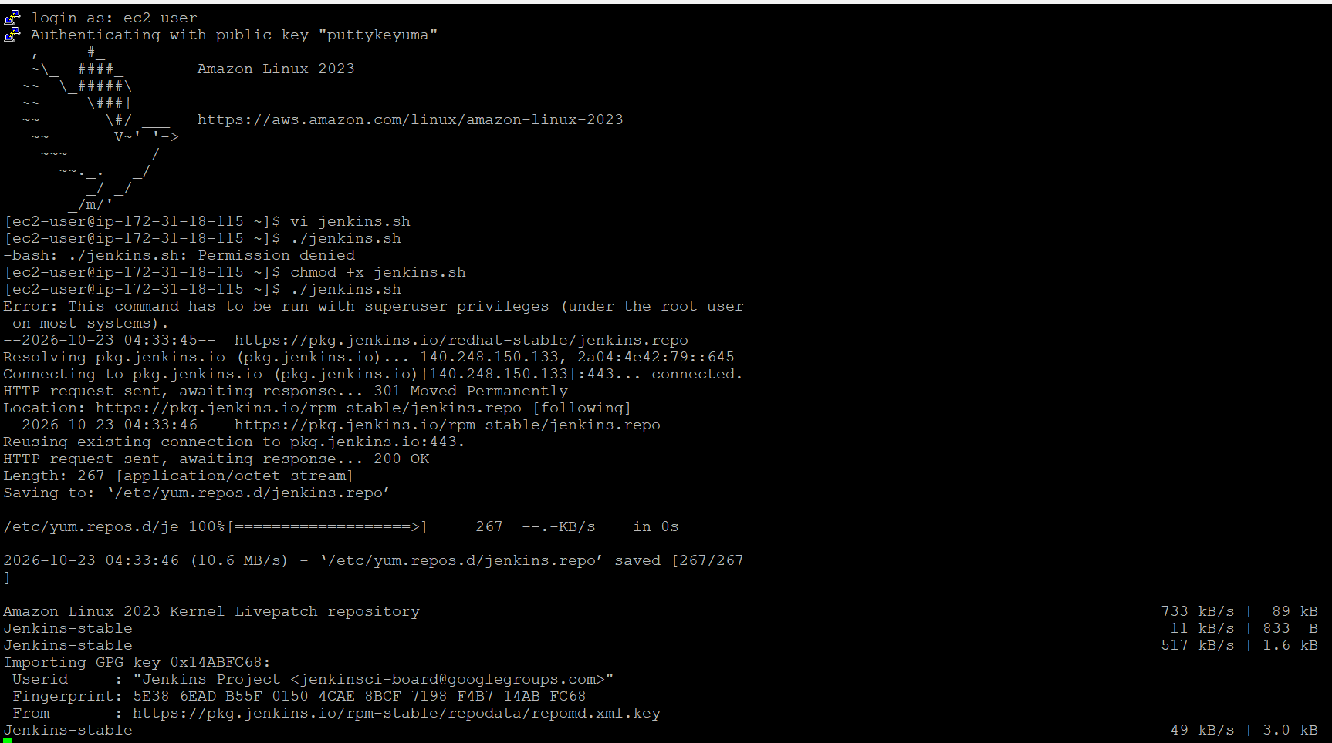
#!/bin/bash
set -e
echo "Updating packages..."
sudo dnf update -y
echo "Installing Git and Maven..."
sudo dnf install -y git maven
echo "Adding Jenkins repository..."
sudo wget -O /etc/yum.repos.d/jenkins.repo https://pkg.jenkins.io/redhat-stable/jenkins.repo
echo "Importing Jenkins Key..."
sudo rpm --import https://pkg.jenkins.io/redhat-stable/jenkins.io-2023.key
echo "Installing Java 21..."
sudo dnf install -y java-21-amazon-corretto
echo "Installing Jenkins..."
sudo dnf install -y jenkins
echo "Reloading systemd..."
sudo systemctl daemon-reload
echo "Enabling Jenkins..."
sudo systemctl enable jenkins
echo "Starting Jenkins..."
sudo systemctl restart jenkins
echo "Checking Jenkins Status..."
sudo systemctl status jenkins --no-pager
echo "Jenkins Initial Password:"
sudo cat /var/lib/jenkins/secrets/initialAdminPassword
echo "Installation Completed"

chmod +x jenkins.sh
http://54.83.83.228:8080
deploy to container –plugin install under manage Jenkins

tomcat server:
tomcat.sh
#!/bin/bash

echo "Installing Java..."
dnf install -y java-21-amazon-corretto wget

echo "Moving to /opt..."
cd /opt

echo "Downloading Tomcat..."
wget https://downloads.apache.org/tomcat/tomcat-9/v9.0.123/bin/apache-tomcat-9.0.123.tar.gz

echo "Extracting Tomcat..."
tar -xzf apache-tomcat-9.0.123.tar.gz

echo "Changing ownership..."
chown -R ec2-user:ec2-user apache-tomcat-9.0.123

cd apache-tomcat-9.0.123

echo "Configuring Tomcat Users..."
cat > conf/tomcat-users.xml <<EOF
<?xml version="1.0" encoding="UTF-8"?>
<tomcat-users>
<role rolename="manager-gui"/>
<role rolename="admin-gui"/>
<user username="admin"
password="admin123"
roles="manager-gui,admin-gui"/>
</tomcat-users>
EOF

echo "Allowing Remote Access to Manager App..."
cat > webapps/manager/META-INF/context.xml <<EOF
<Context antiResourceLocking="false" privileged="true">
</Context>
EOF

echo "Starting Tomcat..."
chmod +x bin/*.sh
bin/startup.sh

echo "Tomcat Started"
echo "URL: http://<EC2-PUBLIC-IP>:8080"
echo "Manager URL: http://<EC2-PUBLIC-IP>:8080/manager/html"
echo "Username: admin"
echo "Password: admin123"

==============\
[root@ip-172-31-31-121 ~]# vi /opt/apache-tomcat-9.0.123/conf/tomcat-users.xml
<?xml version="1.0" encoding="UTF-8"?>
<tomcat-users>
<role rolename="manager-gui"/>
<role rolename="manager-script"/>
<role rolename="manager-jmx"/>
<role rolename="manager-status"/>
<role rolename="admin-gui"/>
<user username="admin"
password="admin123"
roles="manager-gui,manager-script,manager-jmx,manager-status,admin-gui"/>
</tomcat-users>
cd /opt/apache-tomcat-9.0.123/bin
./shutdown.sh-----./startup.sh

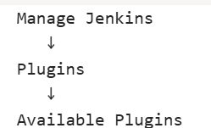
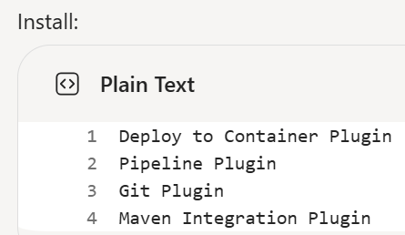
Jenikins:
INSTALLATion:
sudo -i
sudo dnf install java-21-amazon-corretto -y
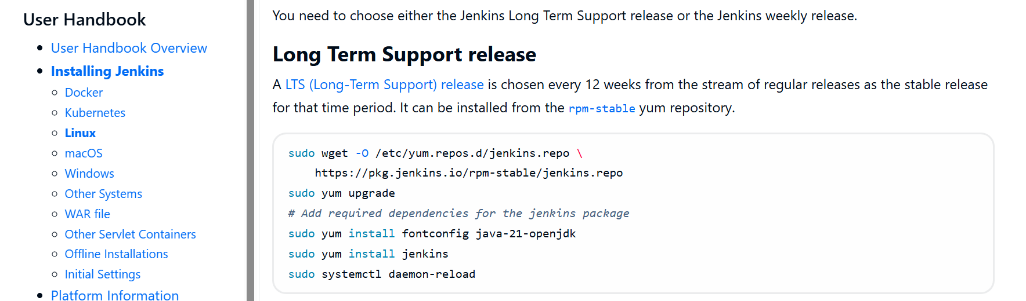
Systemctl start Jenkins
Systemctl status Jenkins
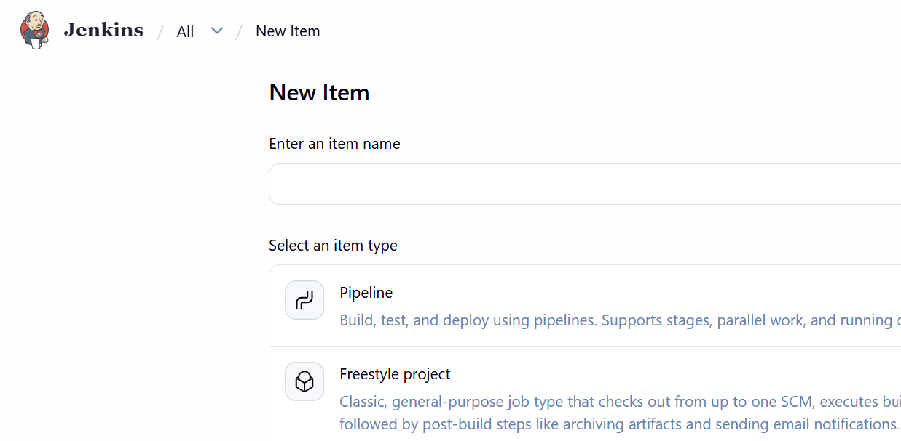
Jenkins: fisrt job==description somthinf===build

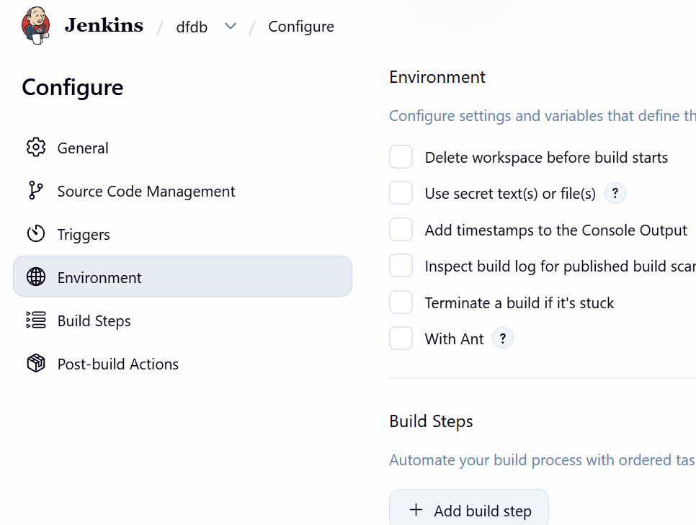
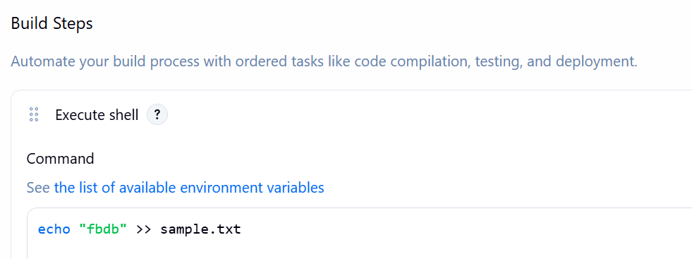
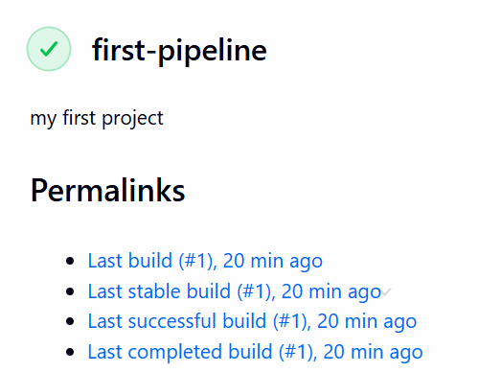
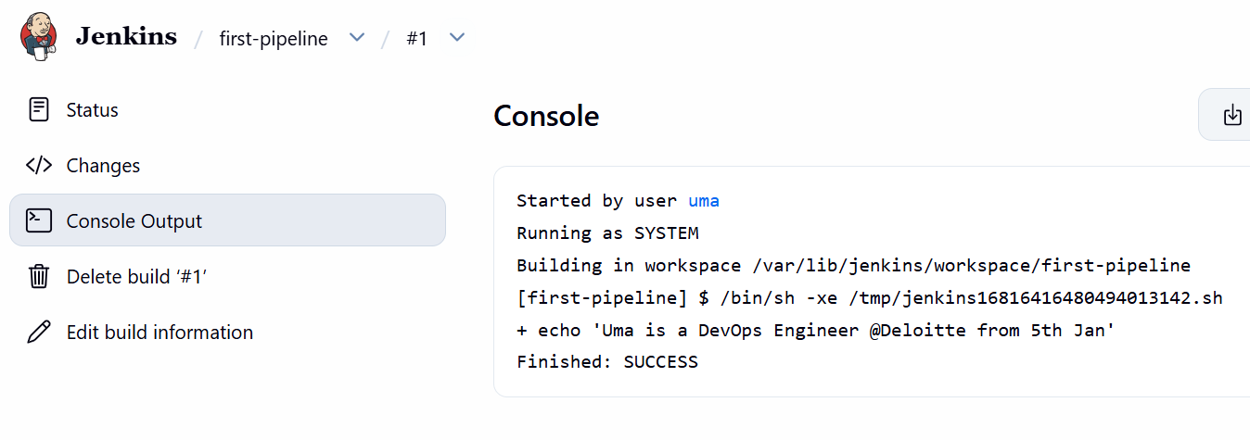
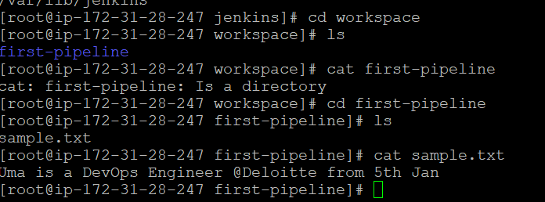
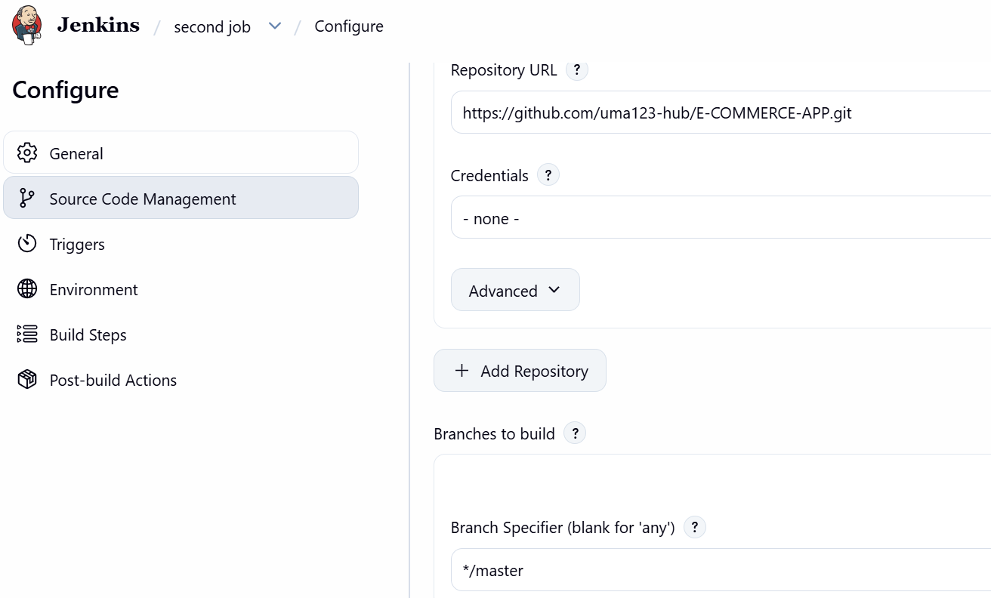

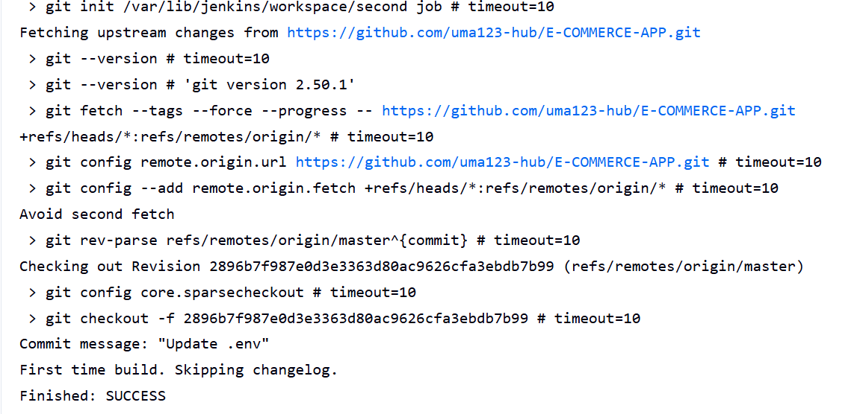
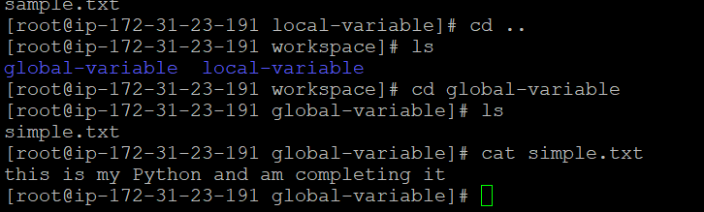
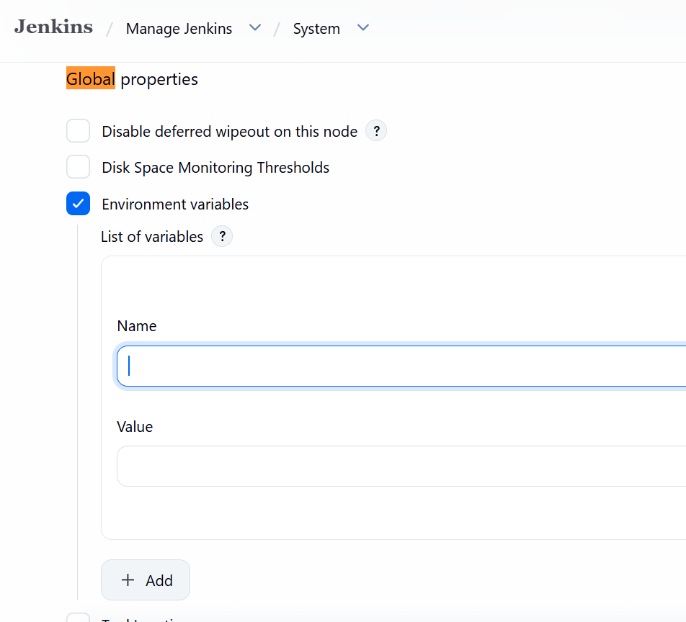
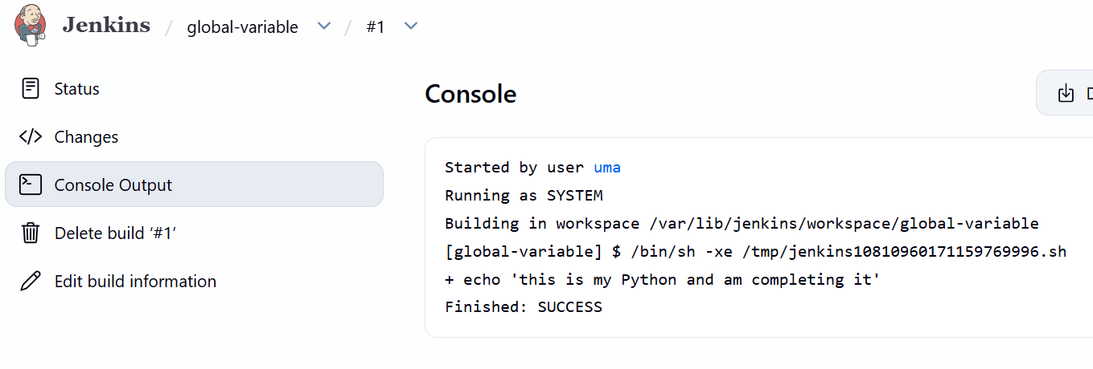
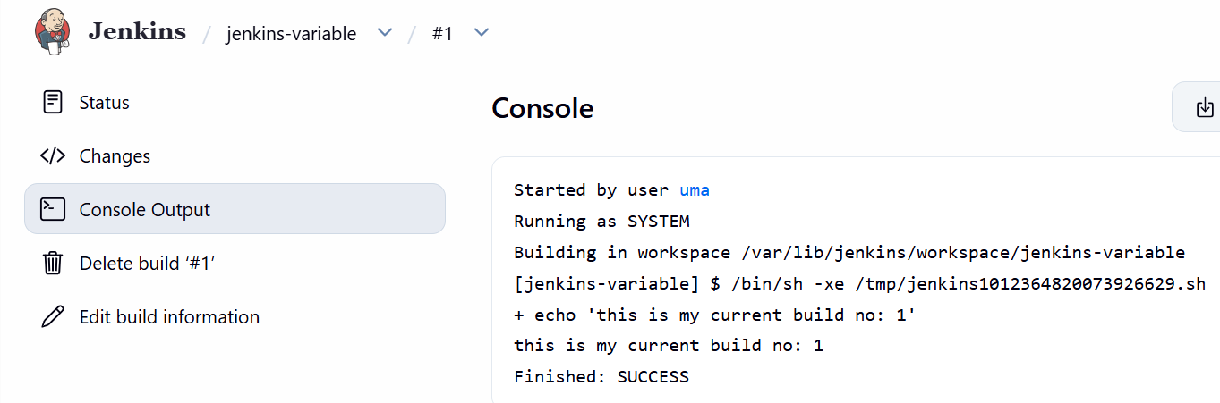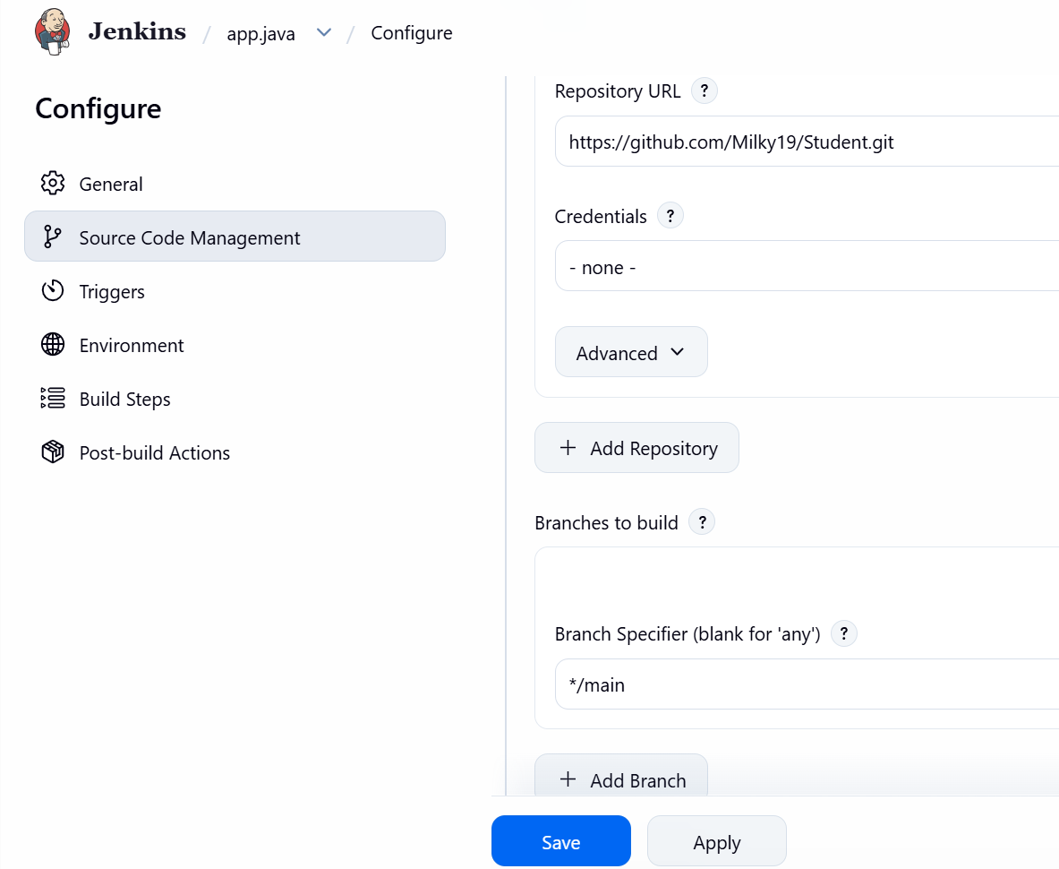
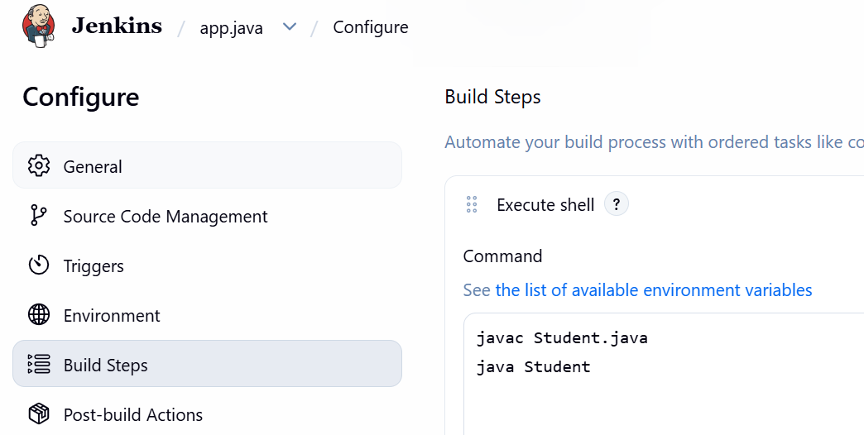
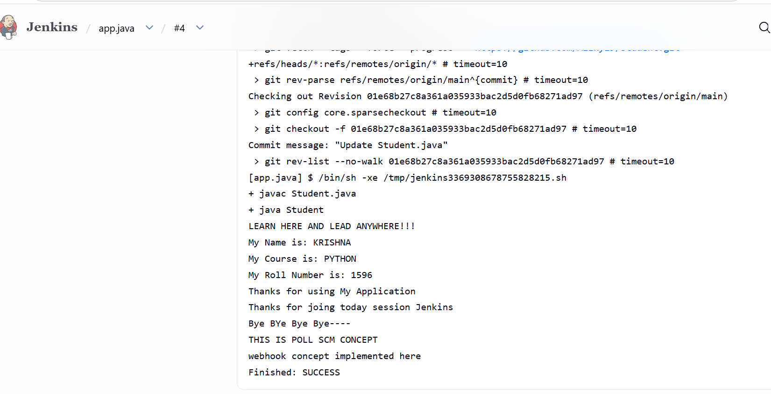

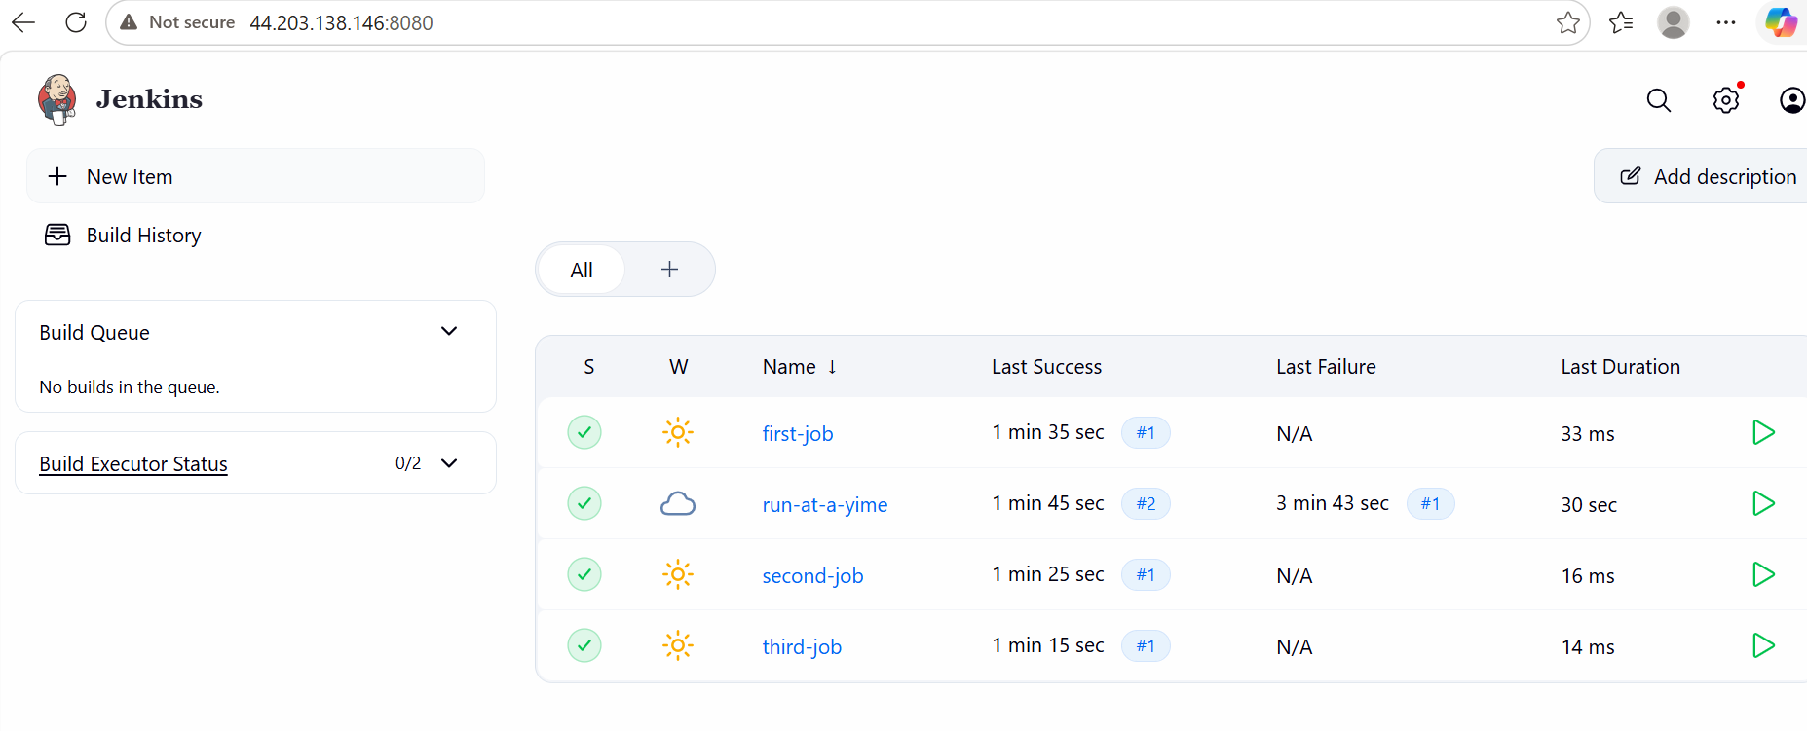
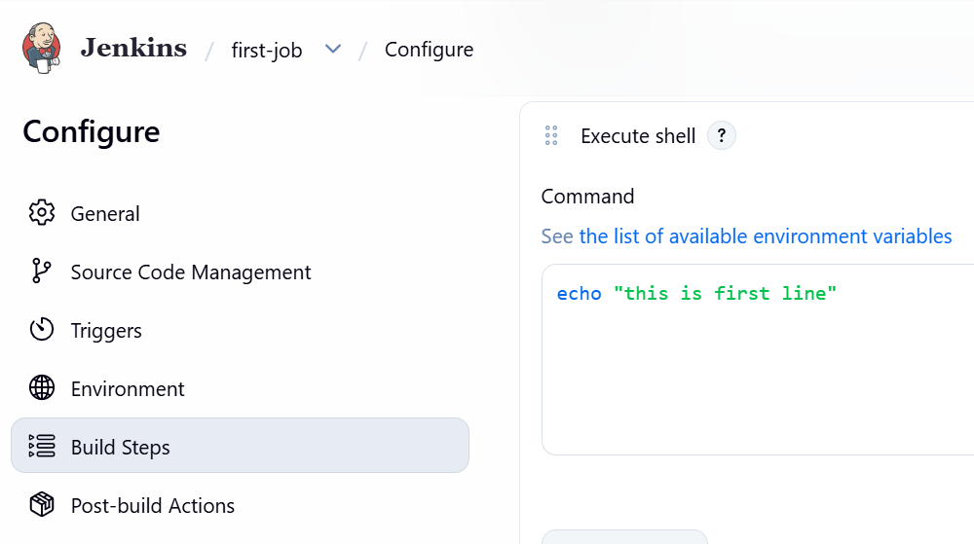

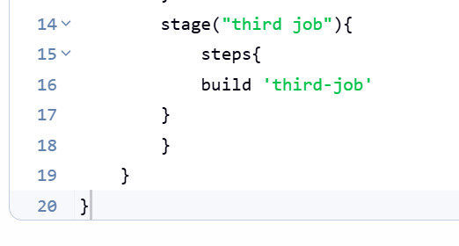
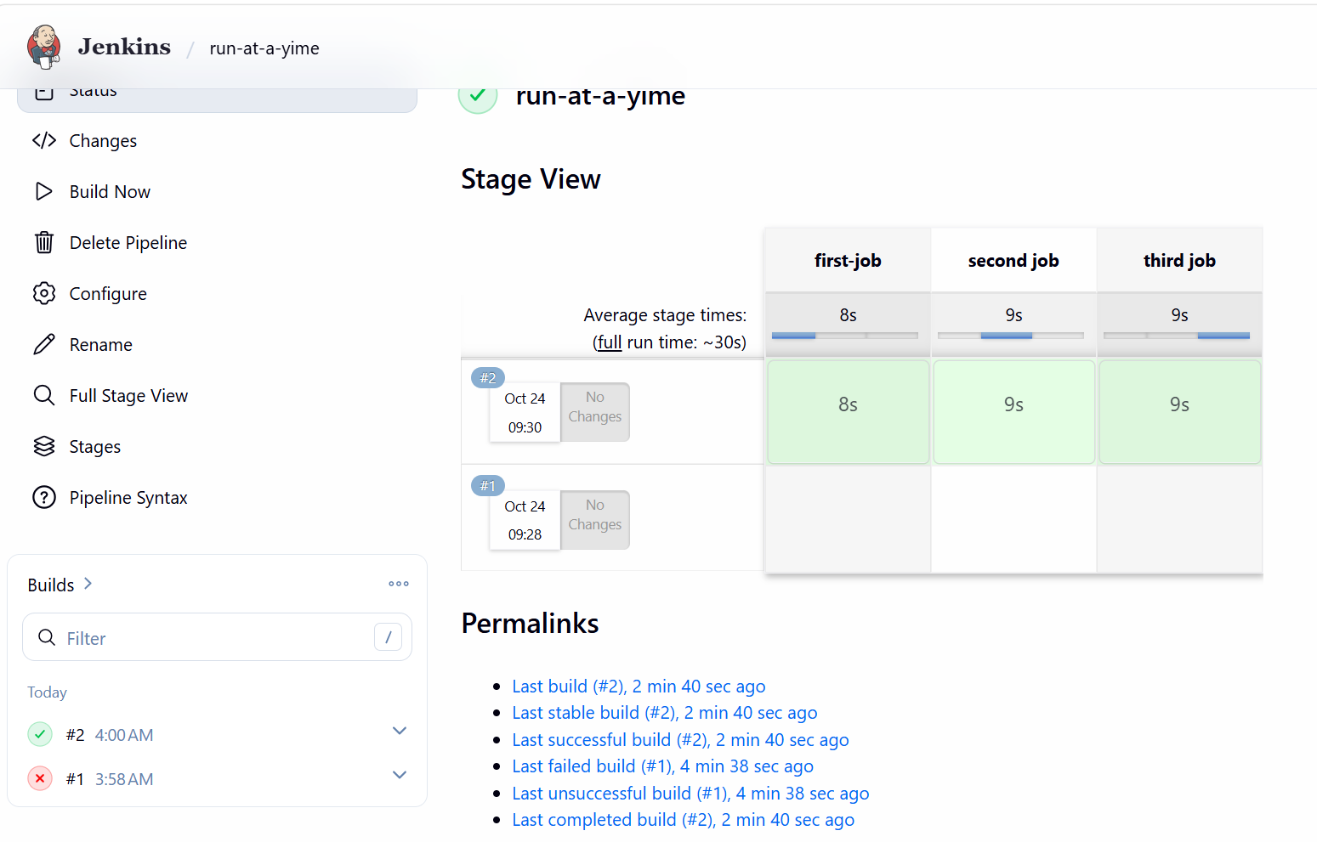

1ST PROJECT:

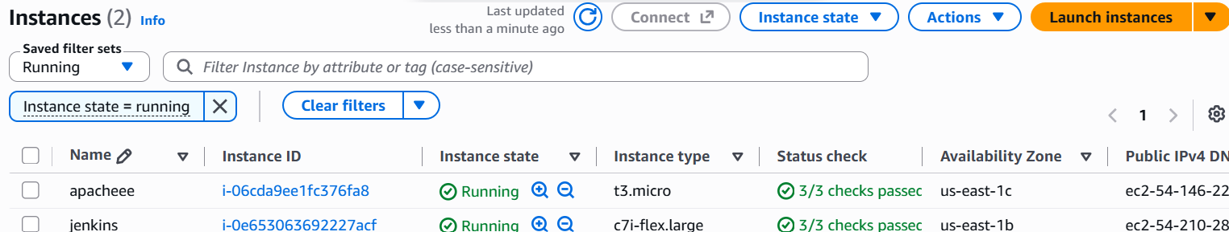
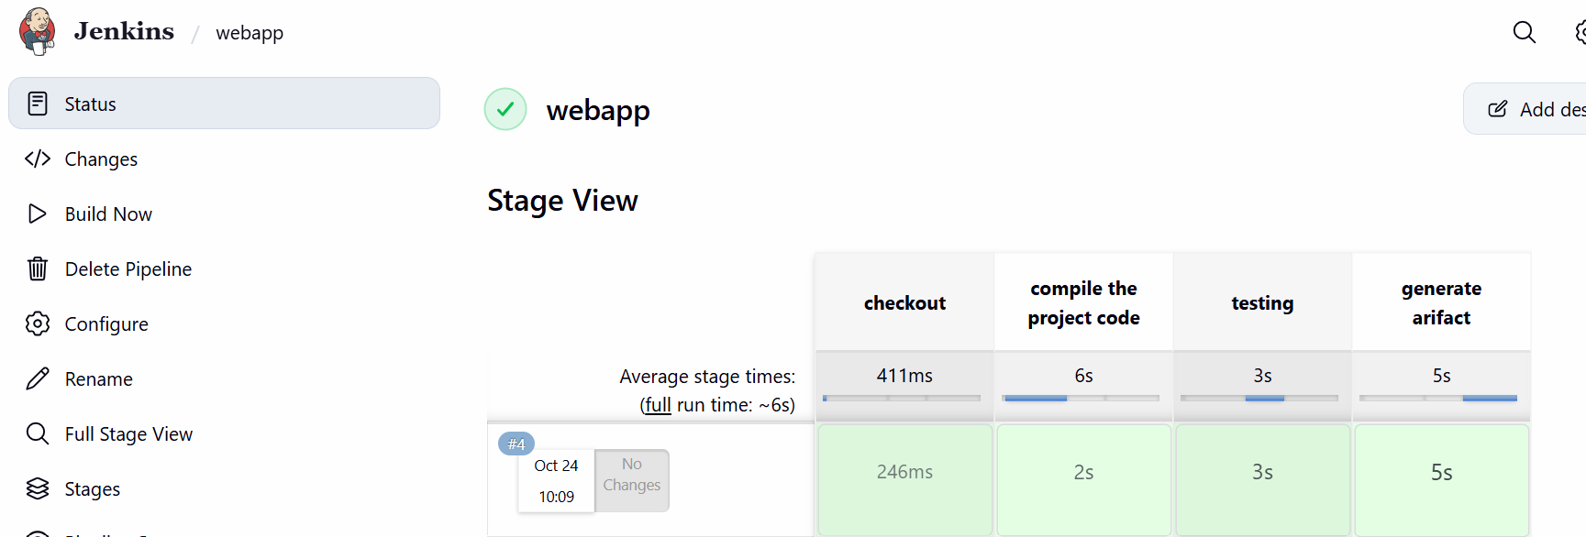
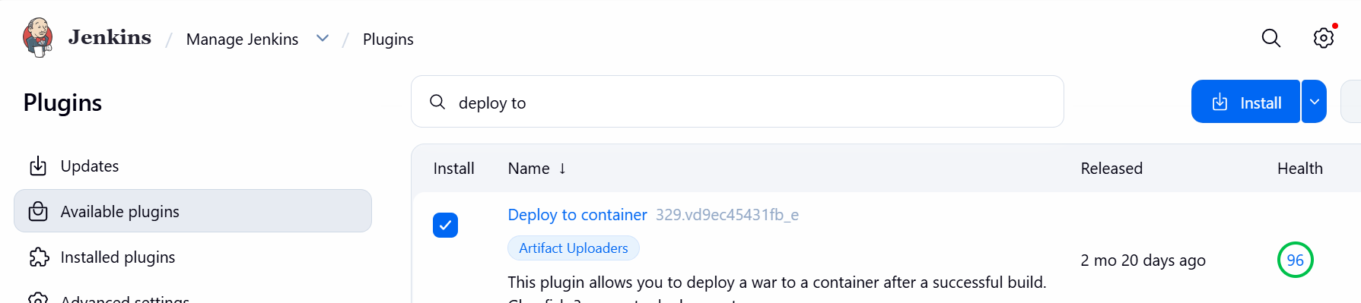
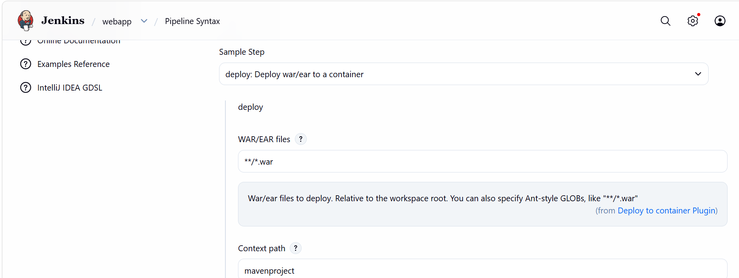
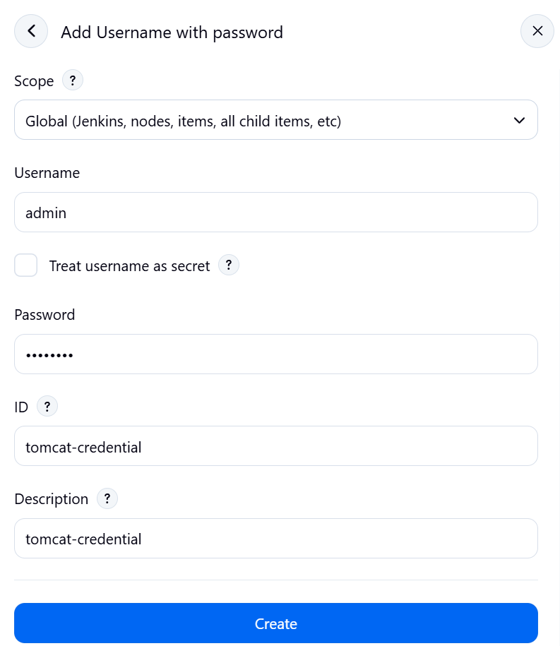
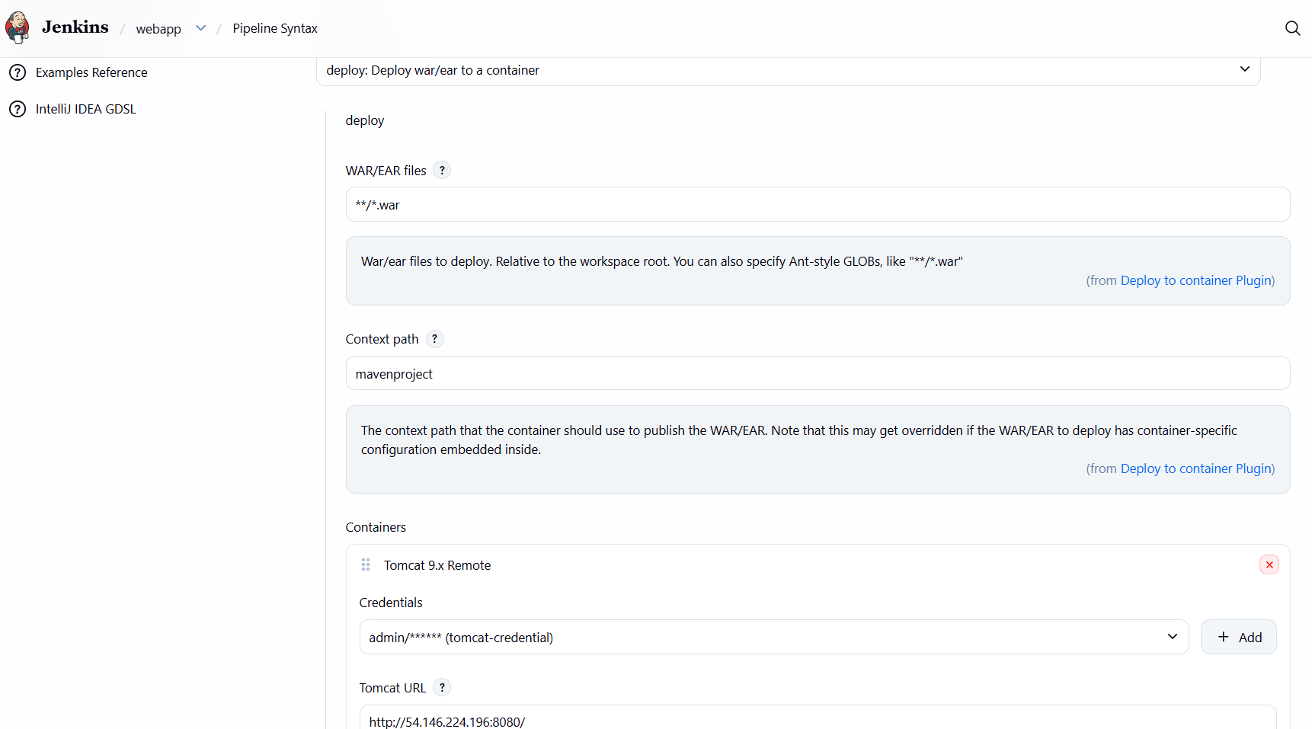
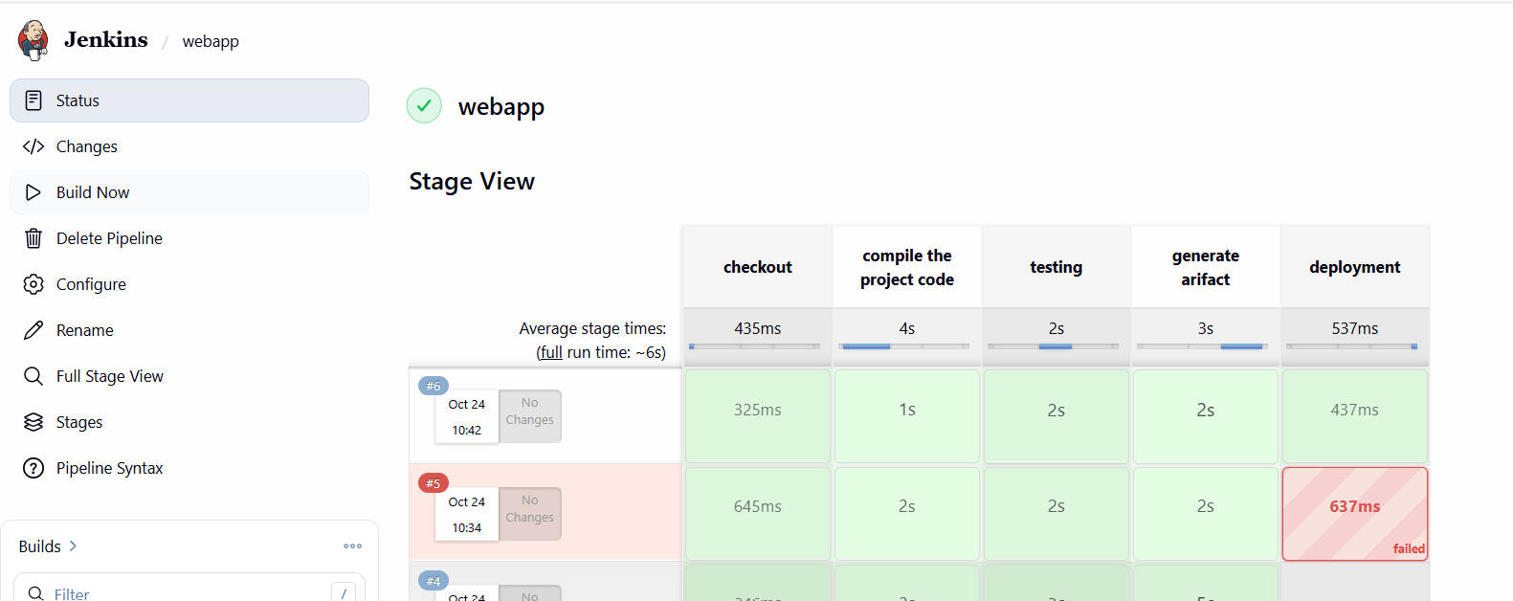

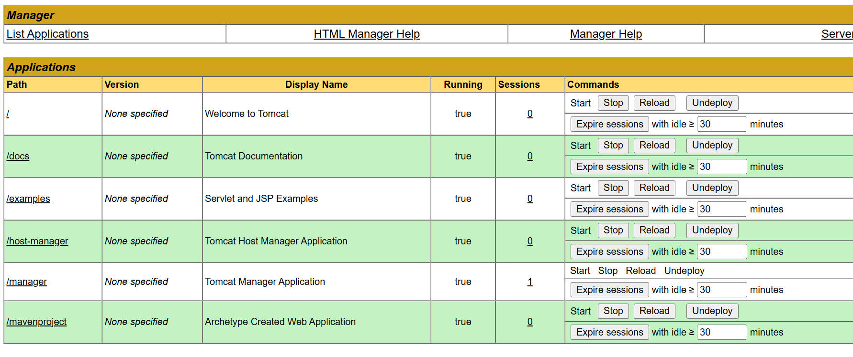
pipeline{
agent any
stages{
stage("checkout"){
steps{
git branch: 'main', url: 'https://github.com/uma123-hub/mavenproject.git'
}
}
stage("compile the project code"){
steps{
sh 'mvn compile'
}
}
stage ("testing"){
steps{
sh 'mvn test'
}
}
stage("generate arifact"){
steps{
sh 'mvn package'
}
}
stage("deployment"){
steps{
deploy adapters: [tomcat9(alternativeDeploymentContext: '', credentialsId: 'tomcat-credential', path: '', url: 'http://54.146.224.196:8080/')], contextPath: 'mavenproject', war: '**/*.war'
}
}
}
}
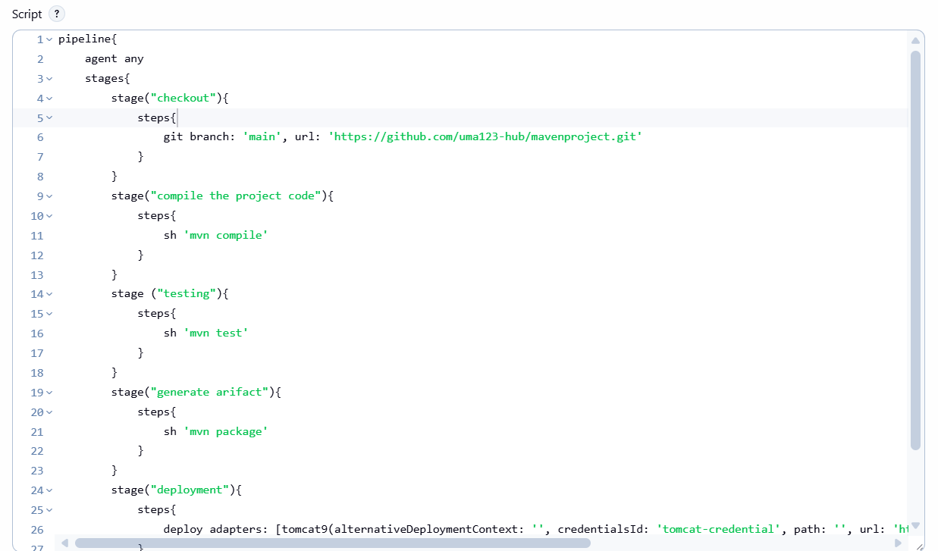
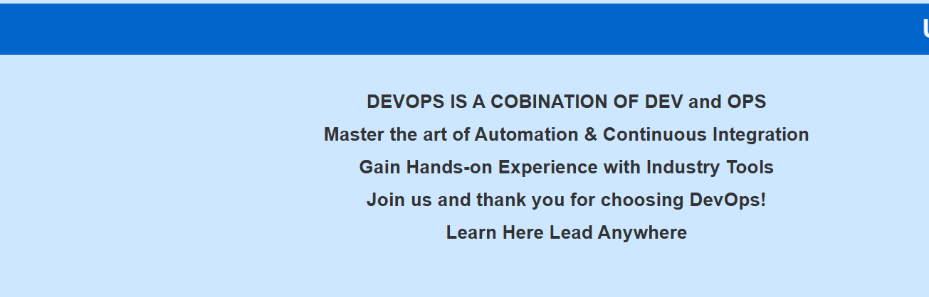

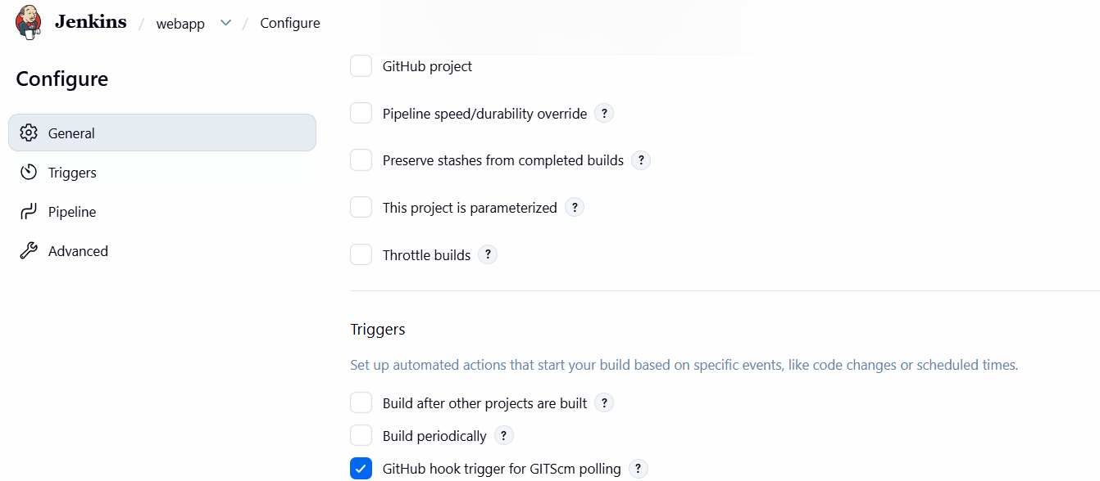

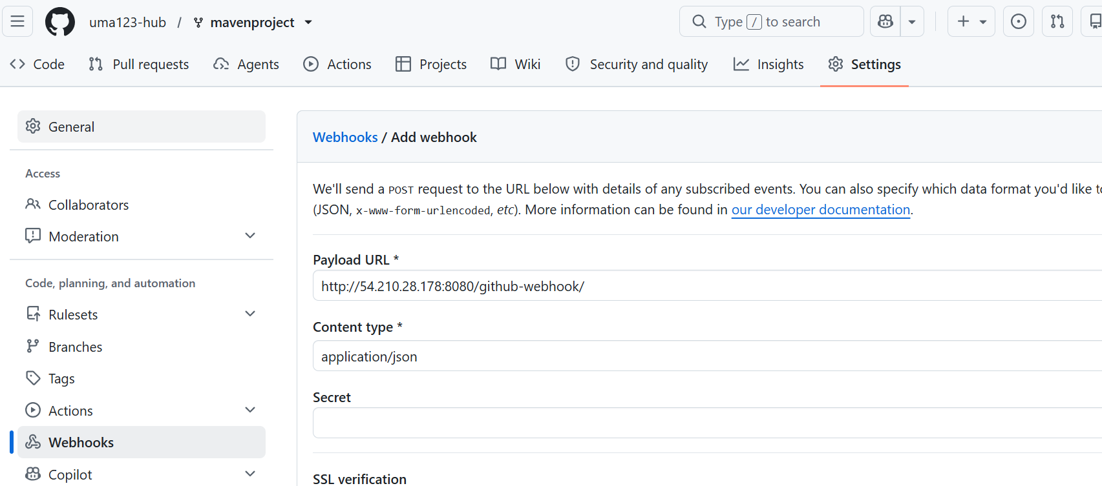
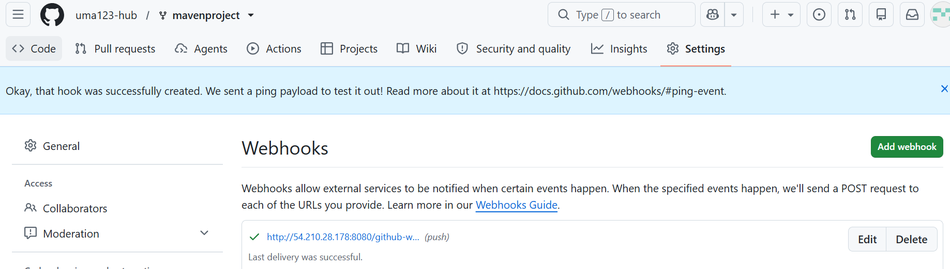

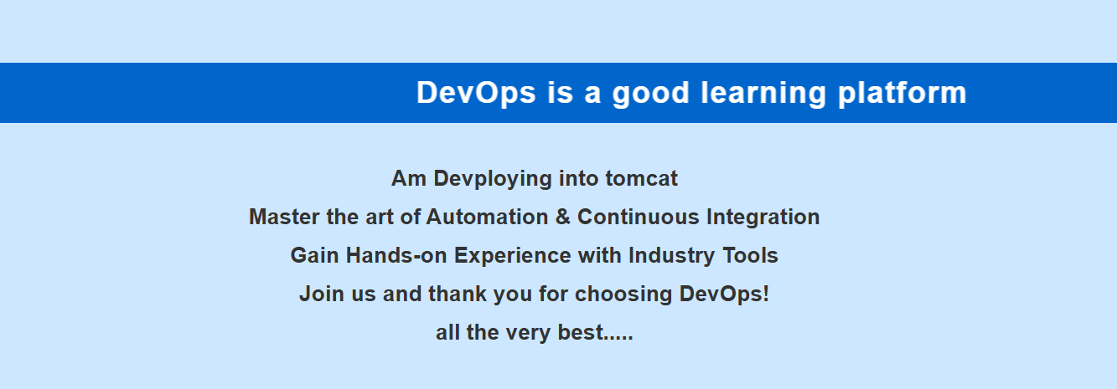
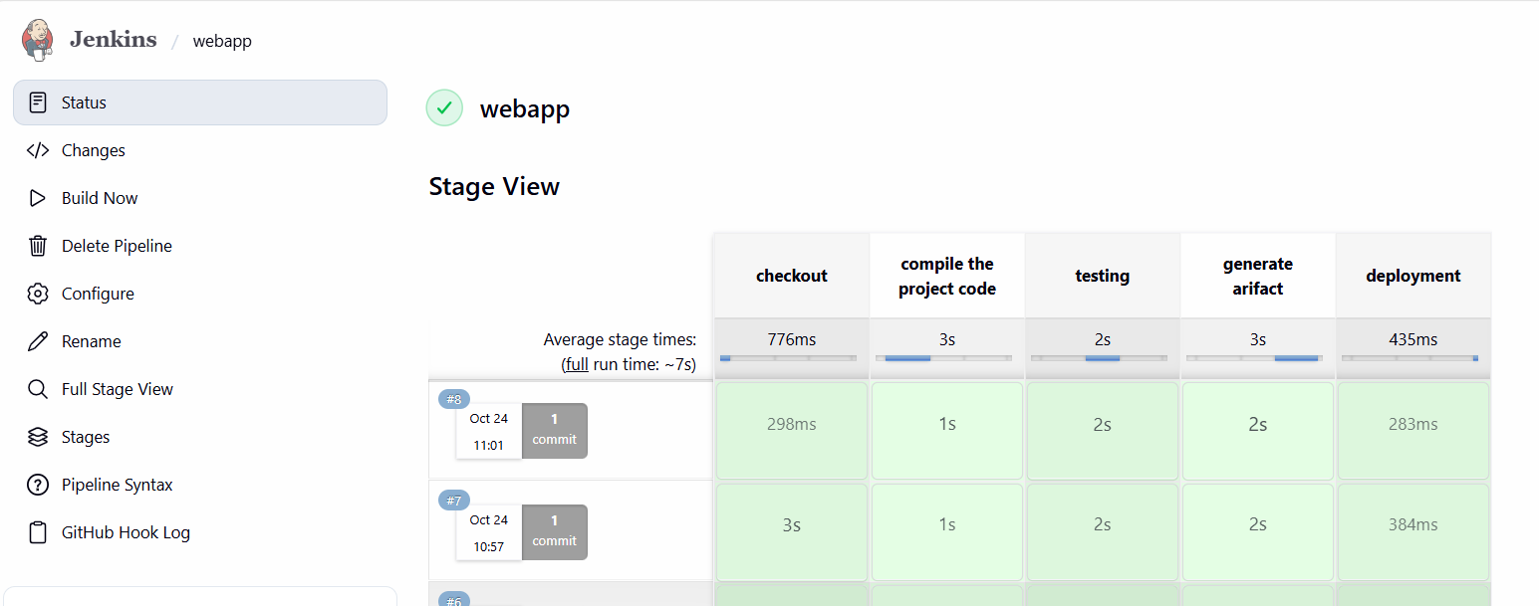
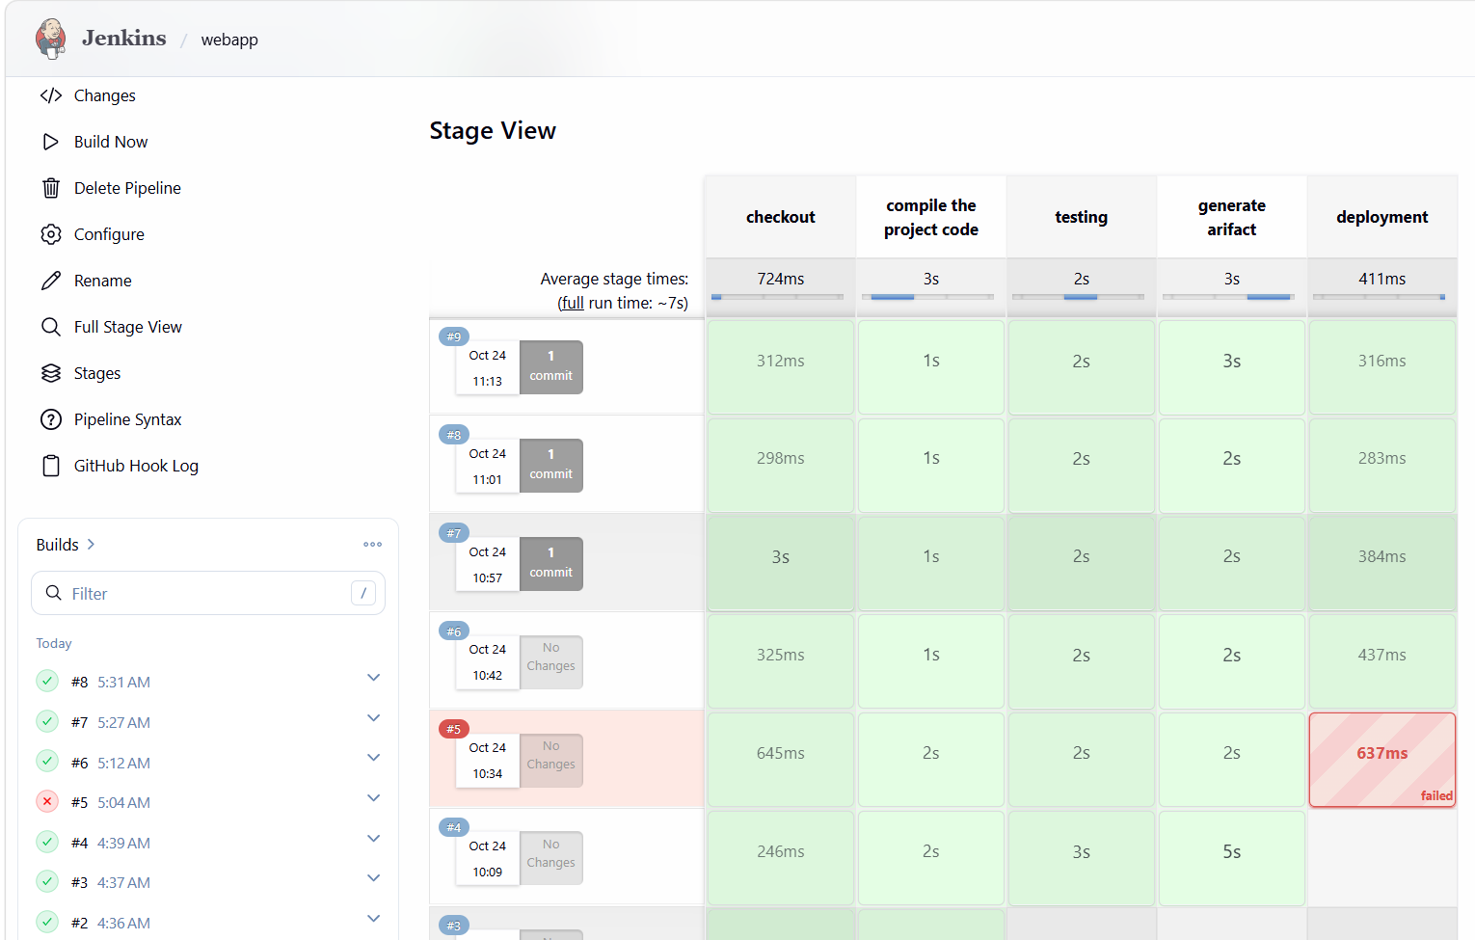
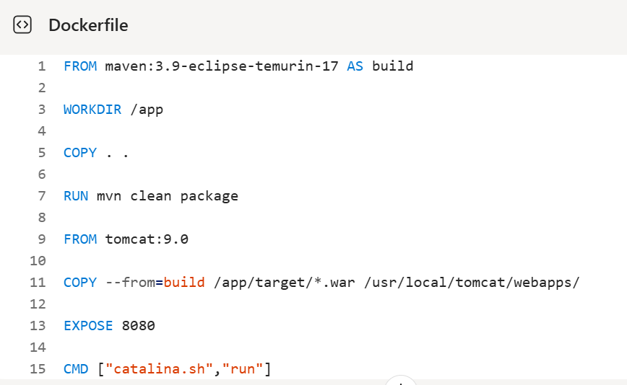
FROM maven:3.9-eclipse-temurin-17 AS build
WORKDIR /app
COPY . .
RUN mvn clean package
FROM tomcat:9.0
COPY --from=build /app/target/*.war /usr/local/tomcat/webapps/
EXPOSE 8080
CMD ["catalina.sh","run"]

==============================================================
Project 2:
Task:
Pipeline should be modified on github and it should be reflect in Jenkins
Add sonarqube testing stage, build docker image—push to ECR
Pull from ECR—deploying it on ec2

Solution:
Installed gitbash----created one git repo -- 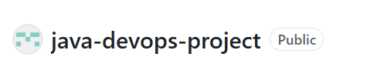
In git bash
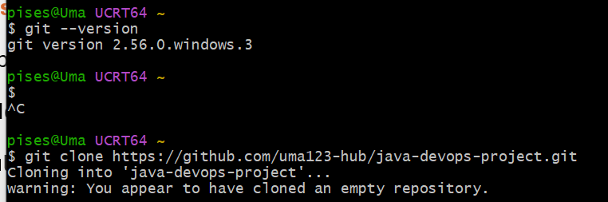
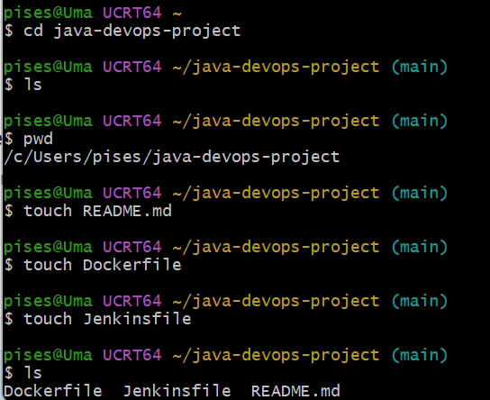
To open file here v need to give --- notepad filename—write—save&close
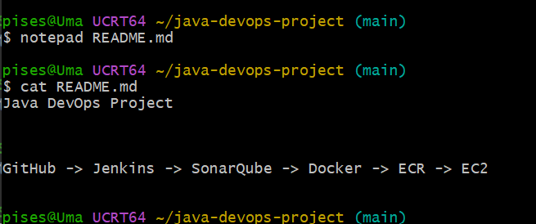

Install jeniks
Install docker -- sudo yum install docker -y
Start Docker: sudo systemctl start docker
Enable at boot: sudo systemctl enable docker
docker –version

Allow Jenkins To Use Docker === sudo usermod -aG docker jenkins
Restart Jenkins: sudo systemctl restart jenkins

Install SonarQube
Pull image: sudo docker pull sonarqube:lts-community
Start SonarQube: sudo docker run -d \
--name sonarqube \
-p 9000:9000 \
sonarqube:lts-community
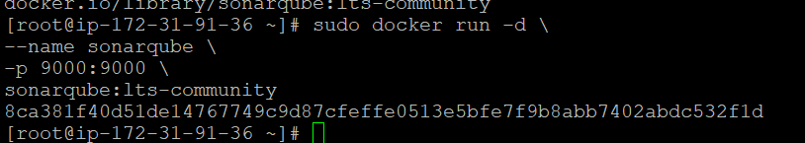

sudo docker ps
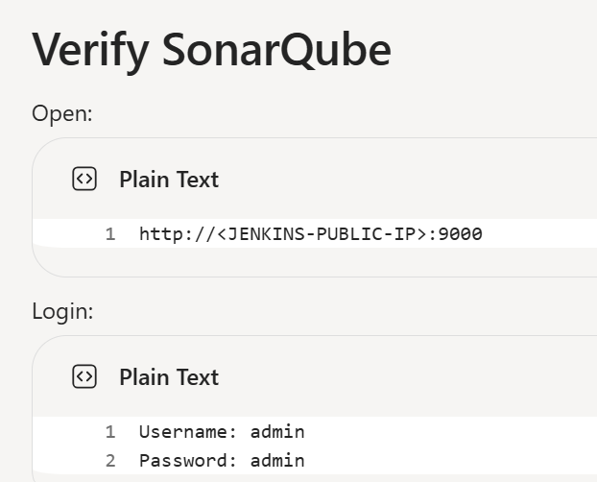
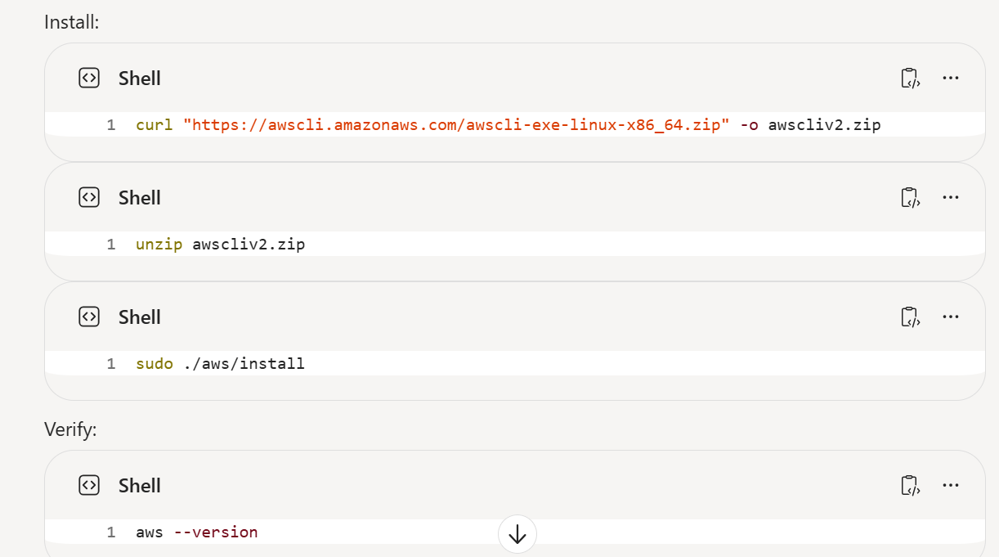
Created iam user
Configure AWS on Jenkins Server
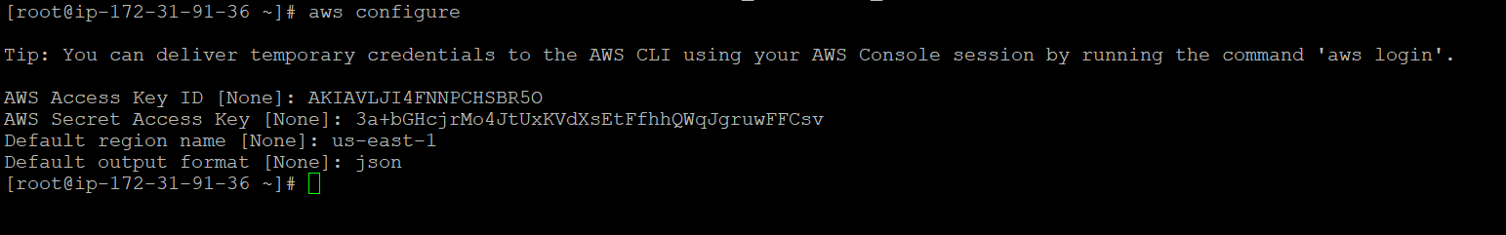
aws sts get-caller-identity---test
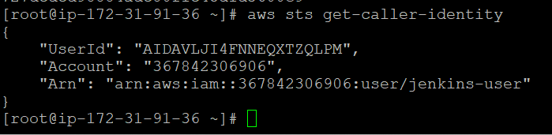
Launched app server
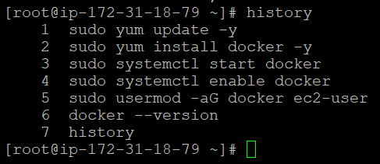
ECR-- 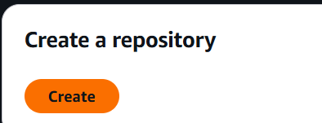== 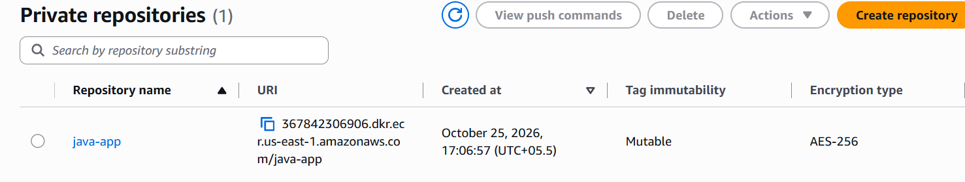
367842306906.dkr.ecr.us-east-1.amazonaws.com/java-app
In Jenkins --- install below plugin---
Git
GitHub
Pipeline
Docker
Docker Pipeline
SonarQube Scanner
AWS Credentials
Publish Over SSH

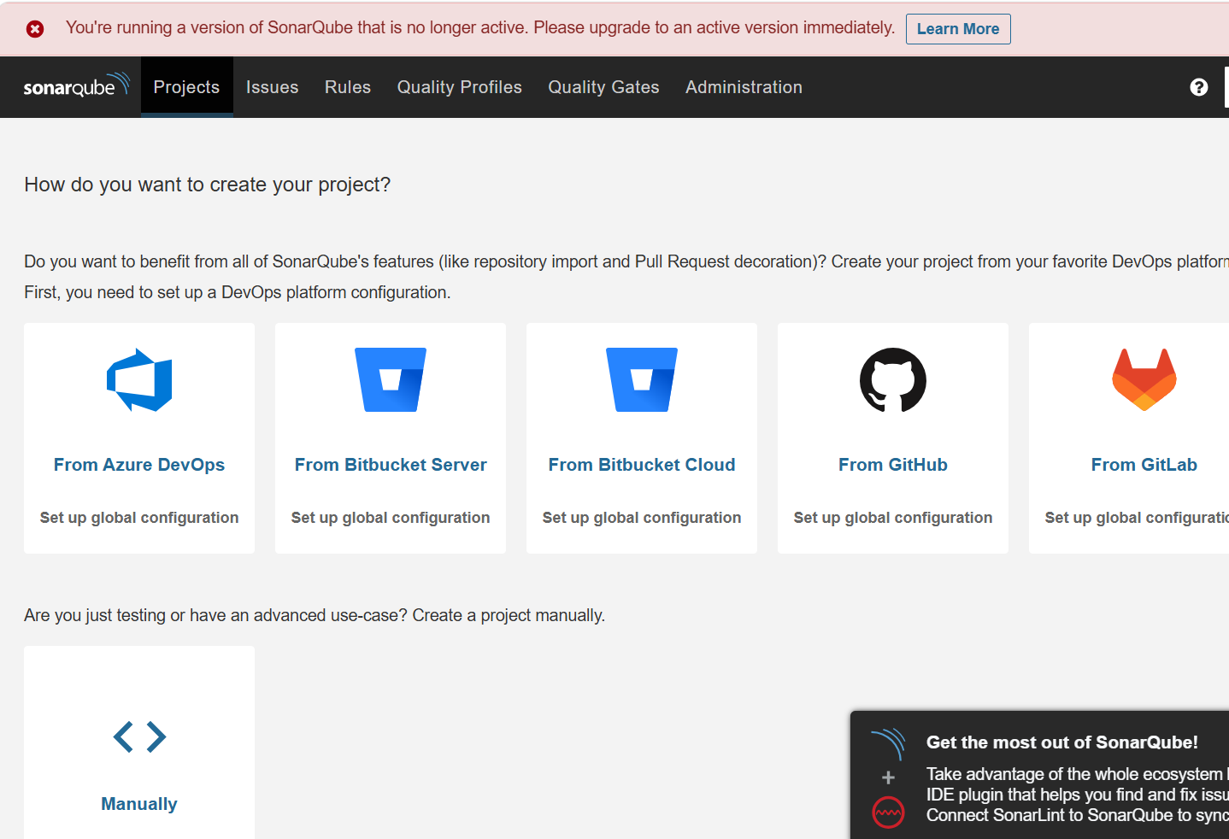
Administration→ Security→ Users→ Tokens
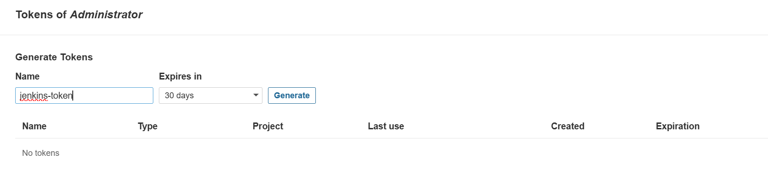
squ_8e509f6c84cf81a83638e8cfd817c8fd30fb266b
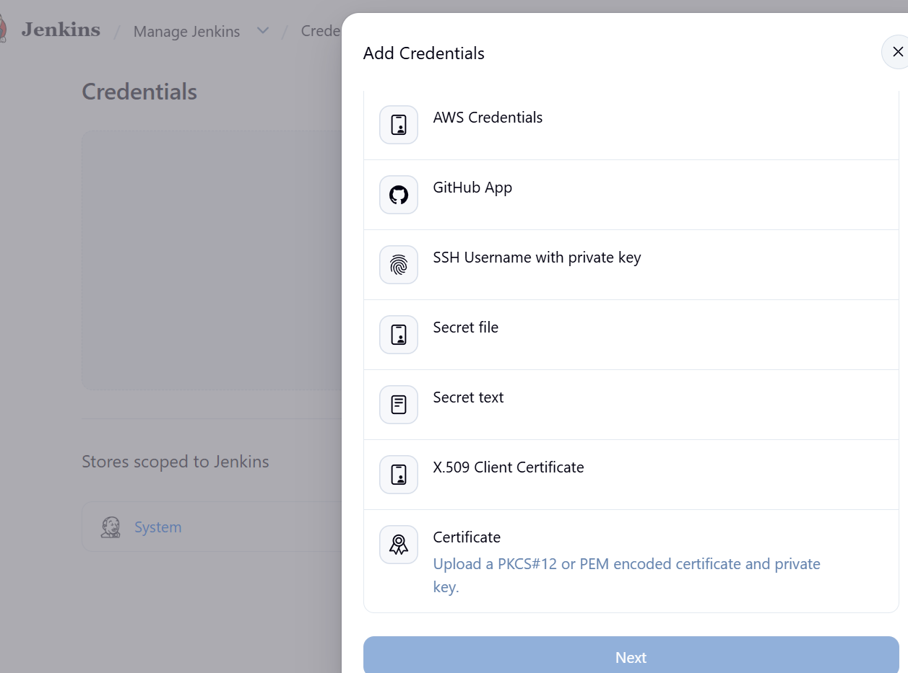
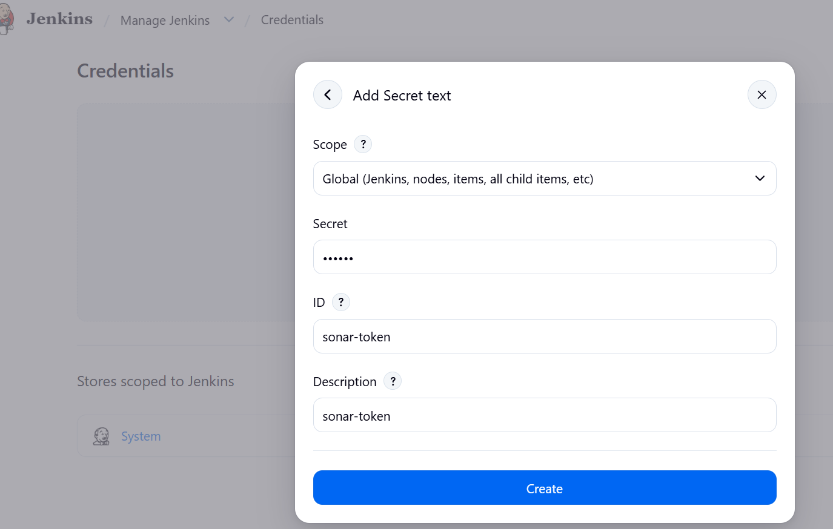
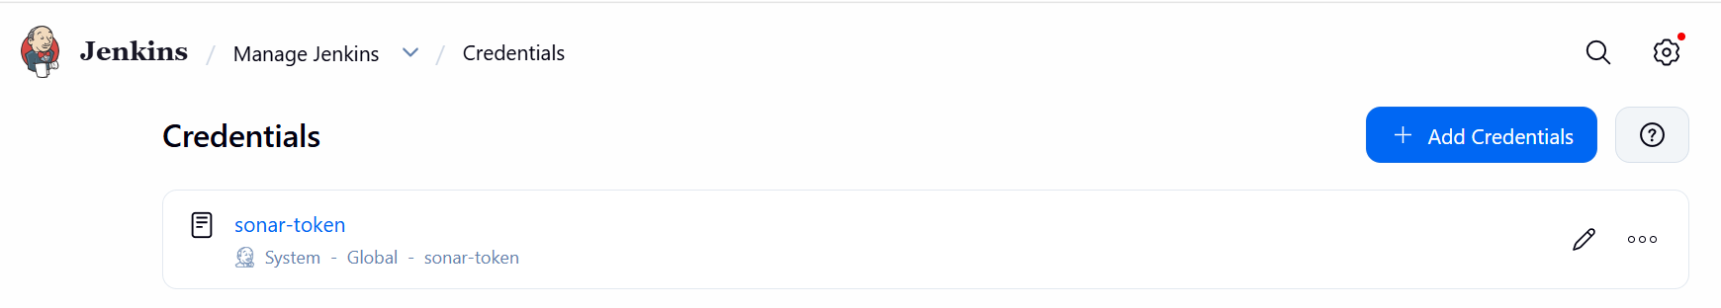
Configure SonarQube Server
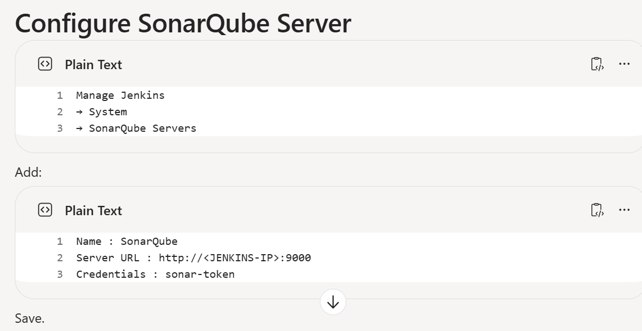
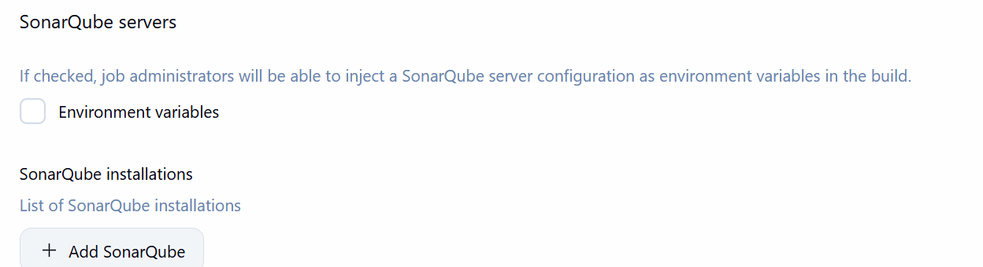
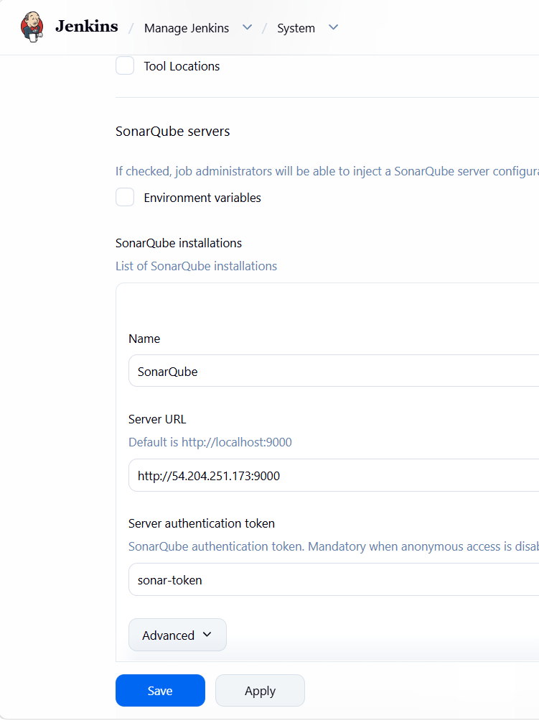
Am building java application—so it contine Spring Boot application
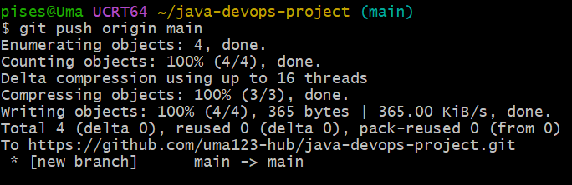
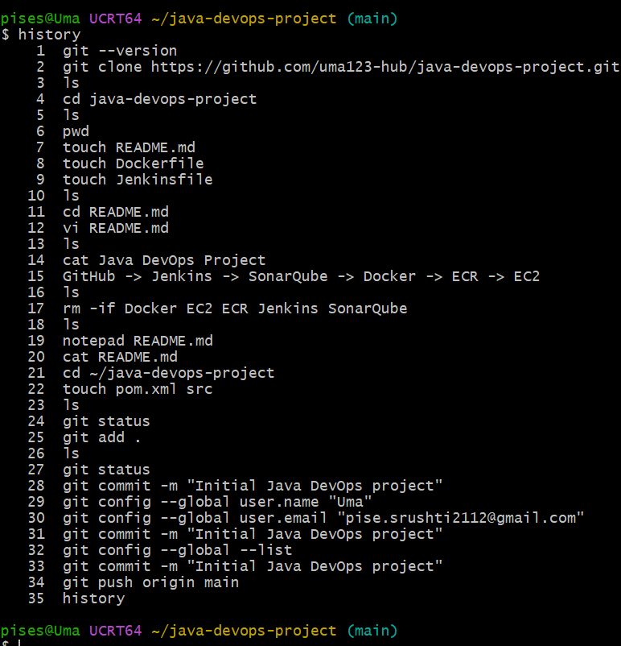
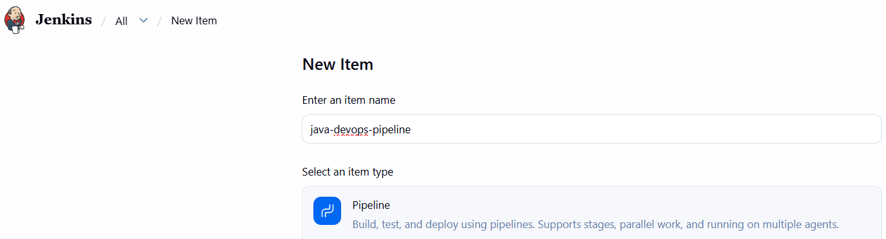
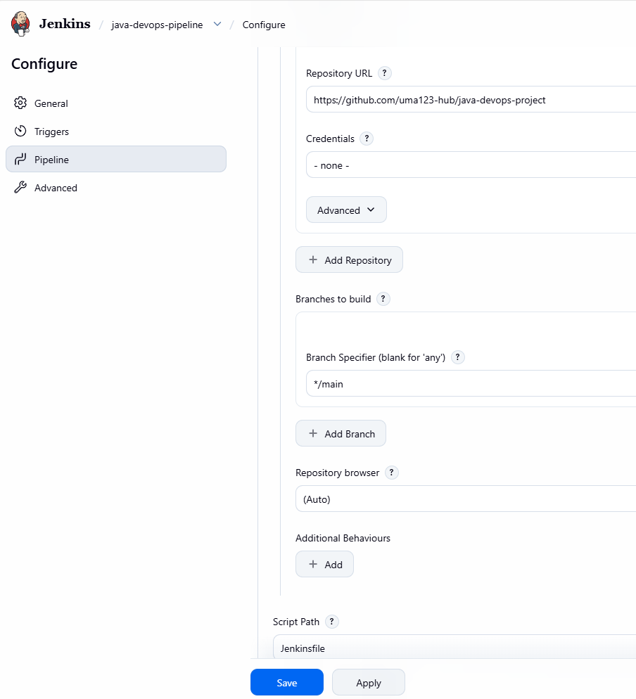
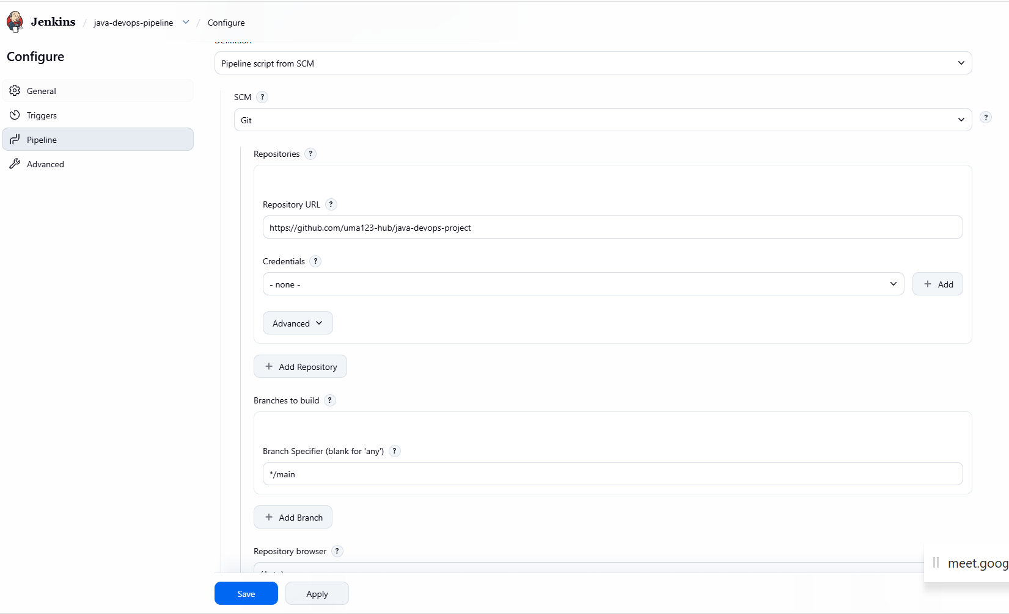
Maven Installations

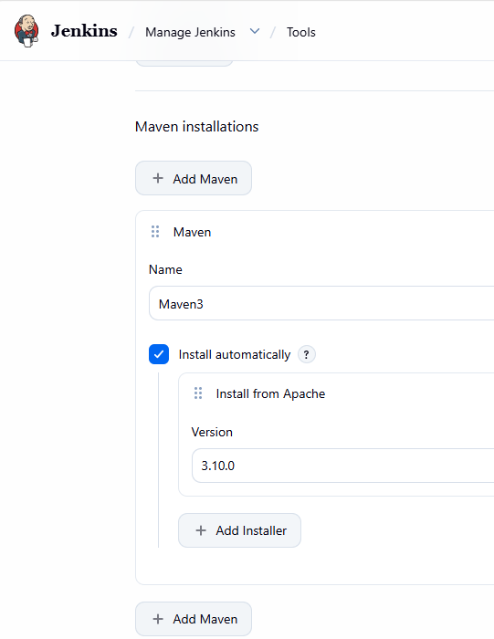
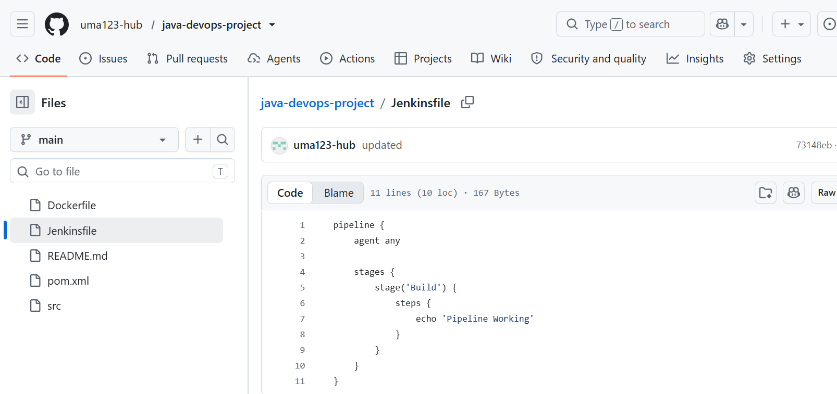

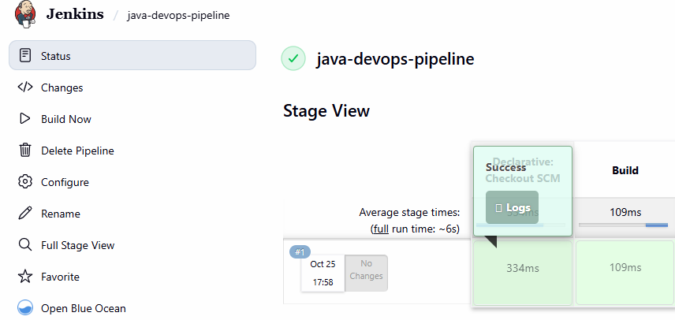
pipeline {
agent any

tools {
maven 'Maven3'
}

stages {

stage('Checkout') {
steps {
checkout scm
}
}

stage('Build') {
steps {
sh 'mvn clean package'
}
}
}
}
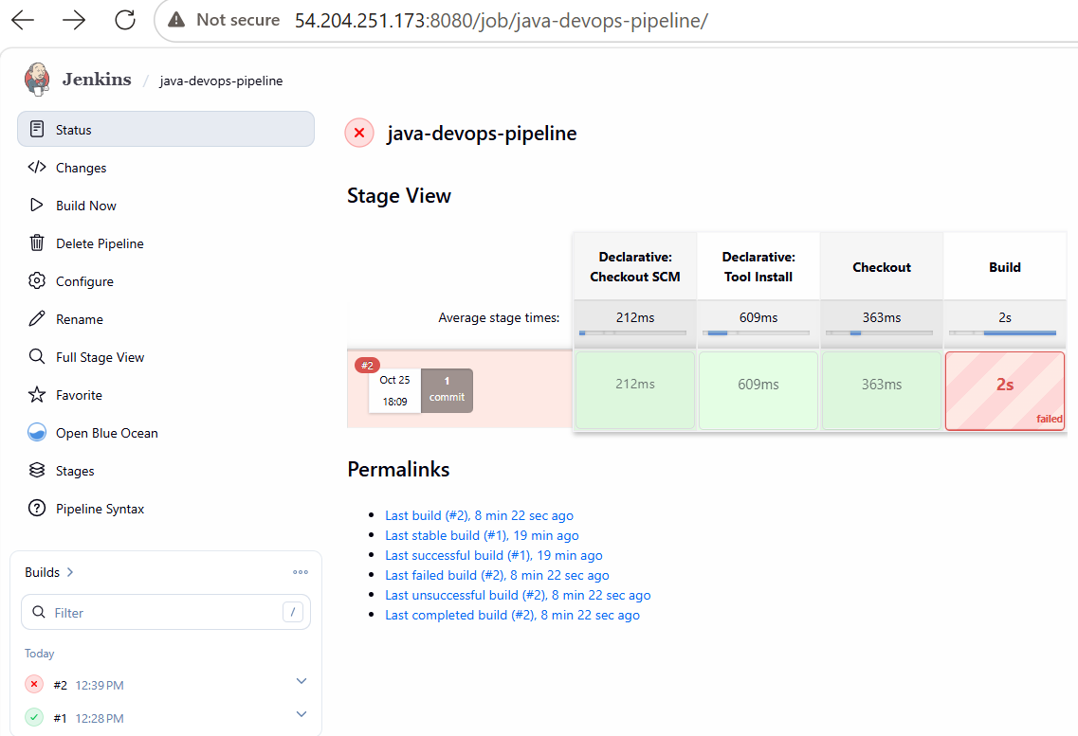
Pom file is empty—so add that---
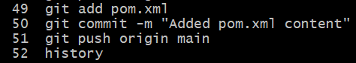
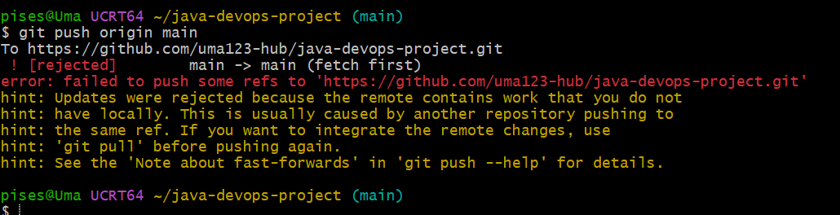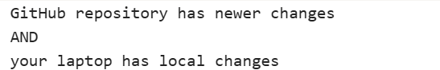
git pull origin main –rebase
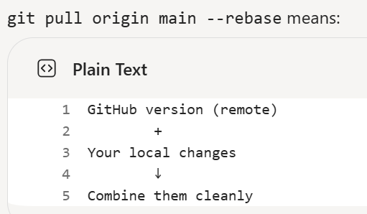
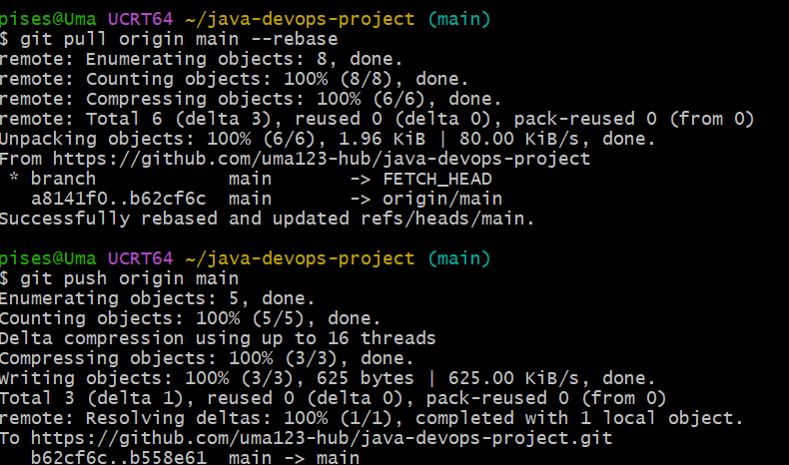
git push origin main
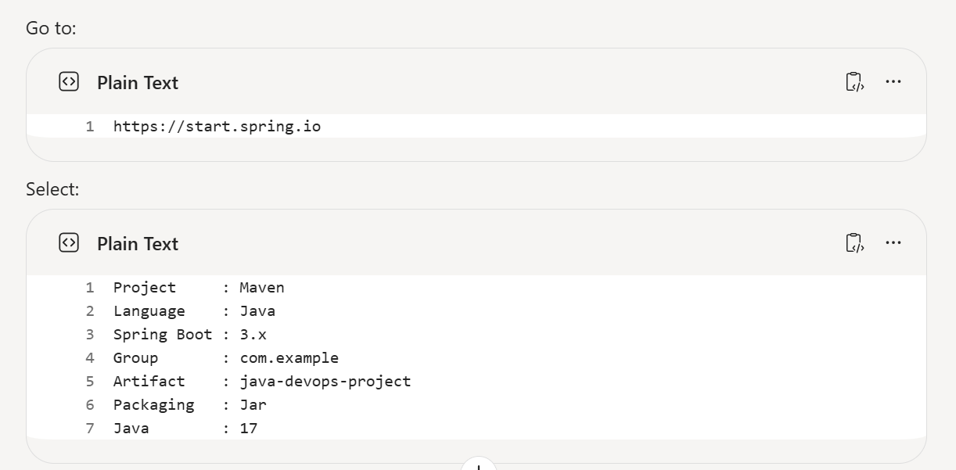
Spring Initializr
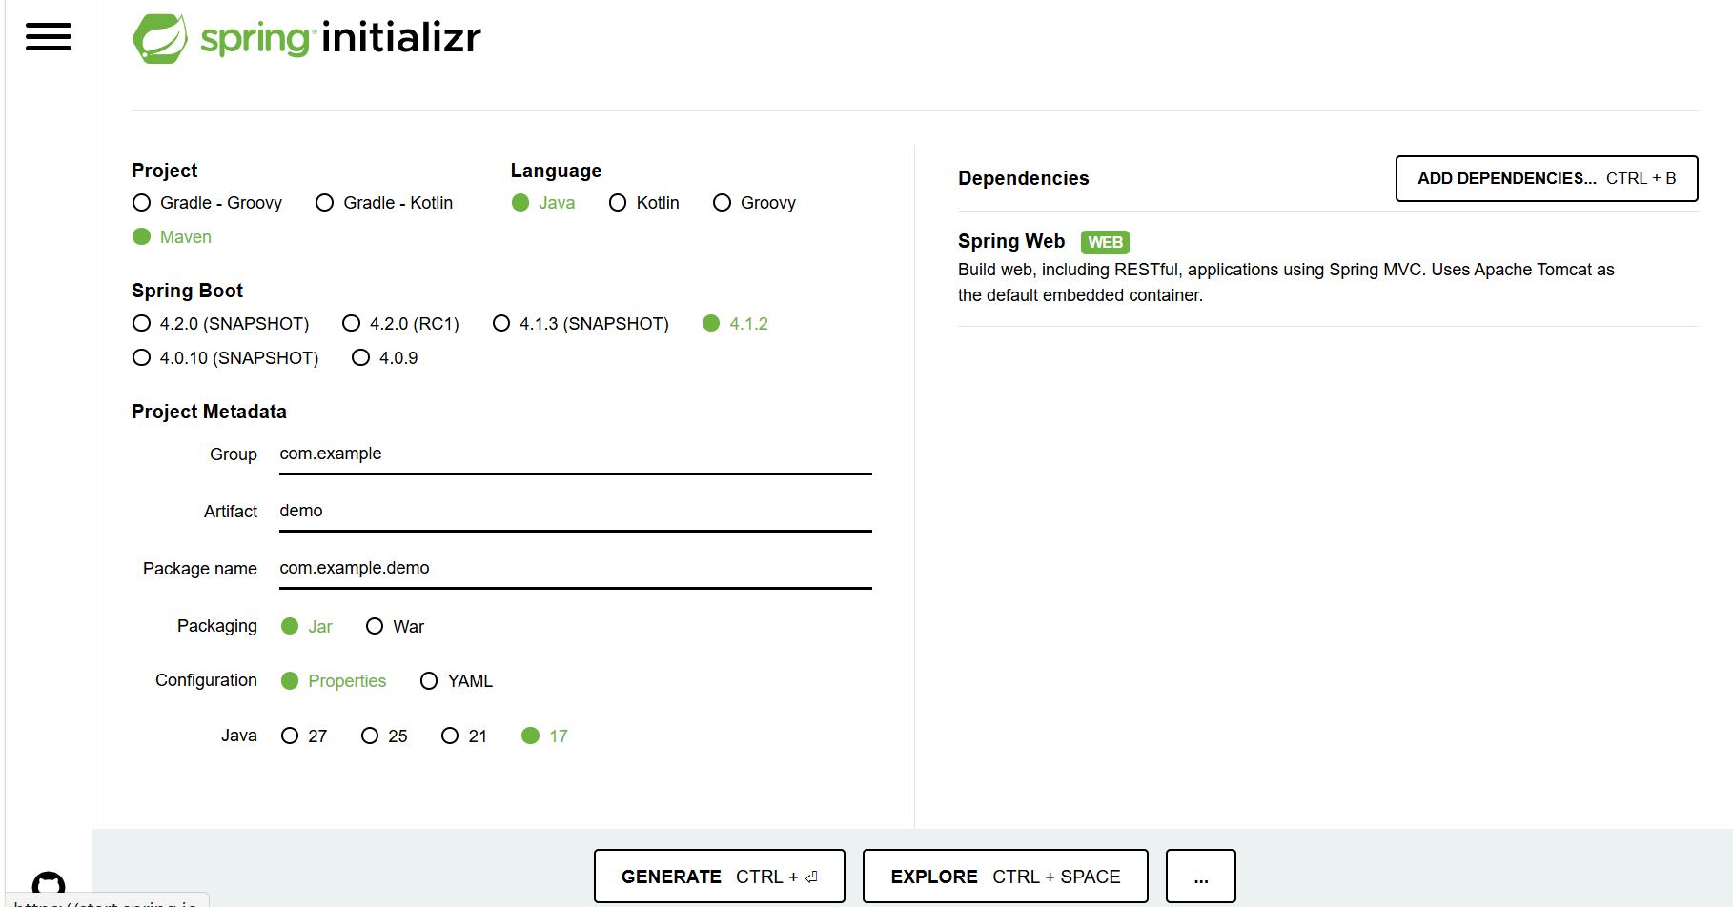

Generate—extract--
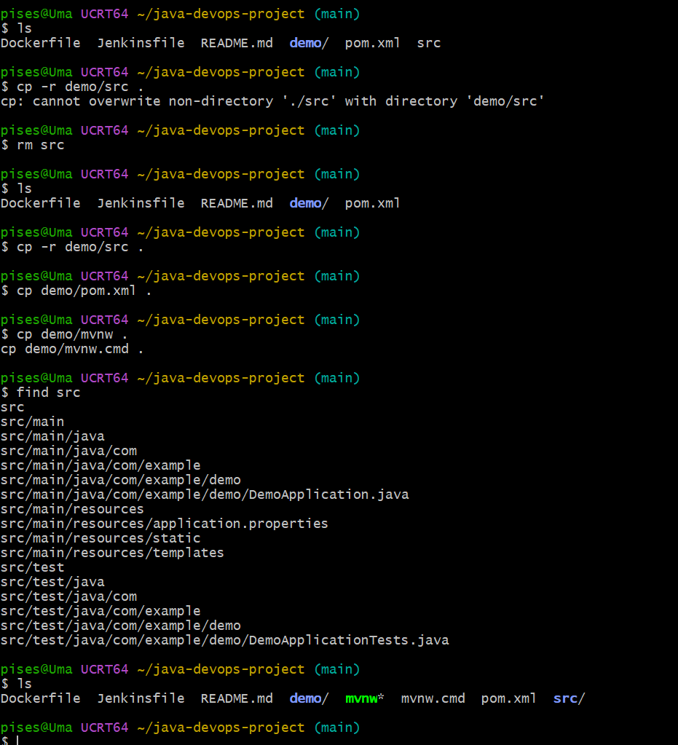

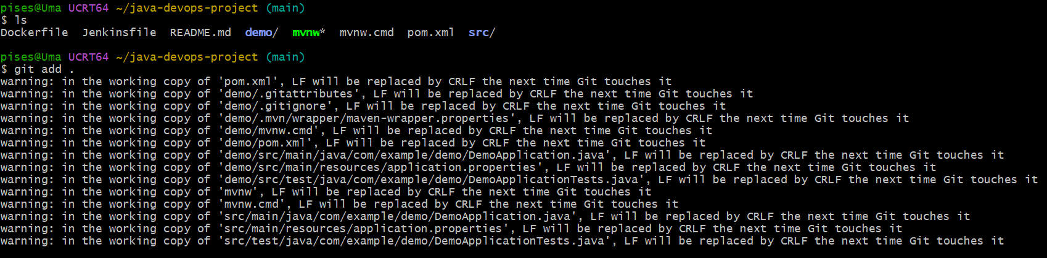
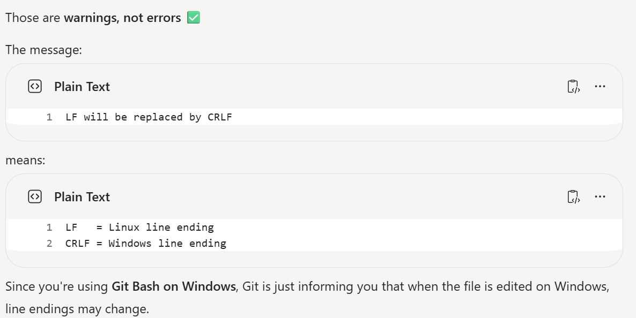
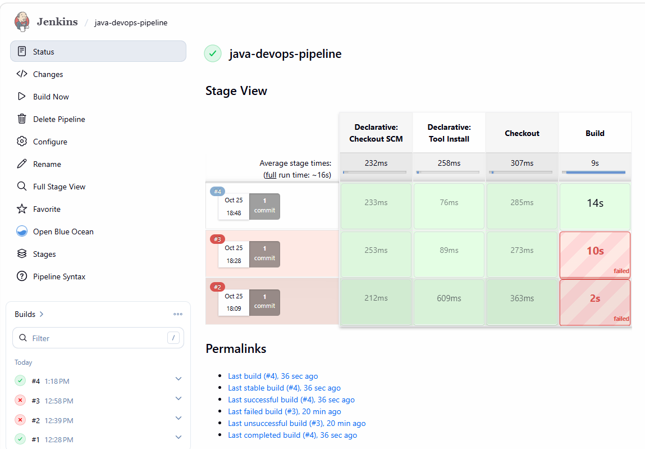
git push origin main
git pull origin main --rebase
git push origin main
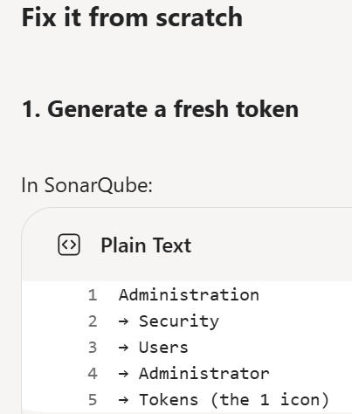
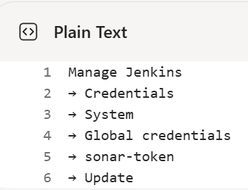
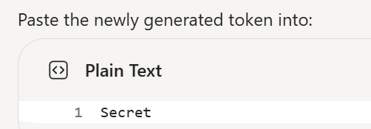

squ_bc30f25c9c2bb88169289852ec98fd547ec514ae ---sonarqube token

pipeline {
agent any

tools {
maven 'Maven3'
}

stages {

stage('Checkout') {
steps {
checkout scm
}
}

stage('Build') {
steps {
sh 'mvn clean package'
}
}

stage('SonarQube Scan') {
steps {
withSonarQubeEnv('SonarQube') {
sh """
mvn org.sonarsource.scanner.maven:sonar-maven-plugin:sonar \
-Dsonar.projectKey=java-devops-project
"""
}
}
}

}

post {
success {
echo 'Build and SonarQube Scan Successful'
}

failure {
echo 'Pipeline Failed'
}
}
}
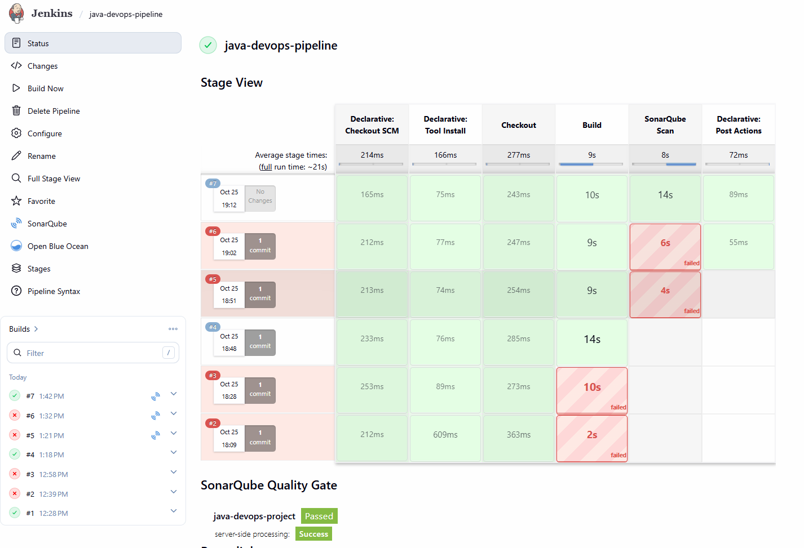
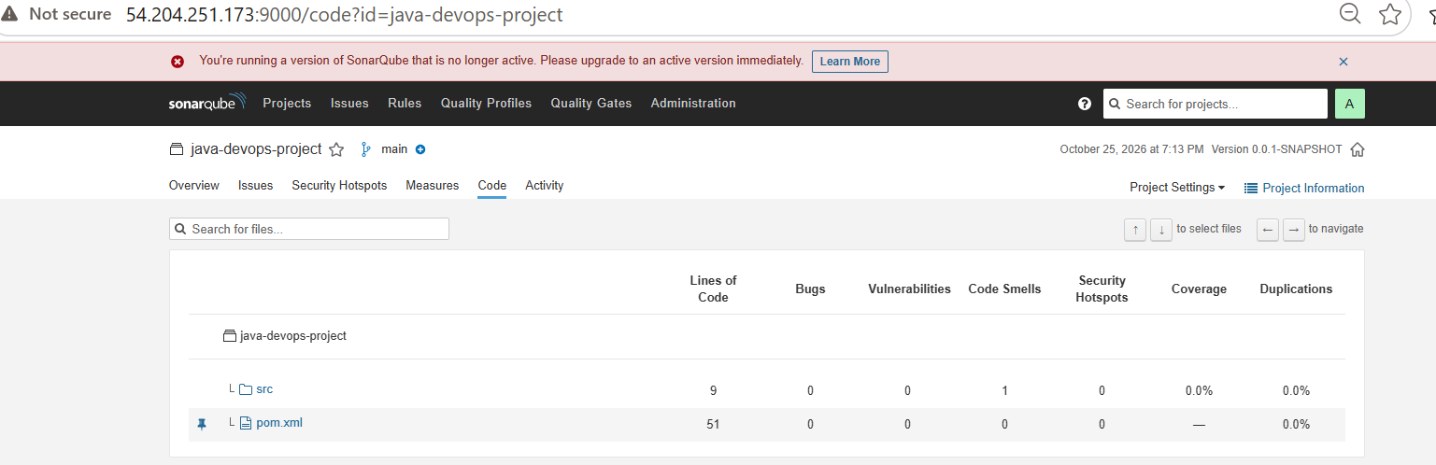
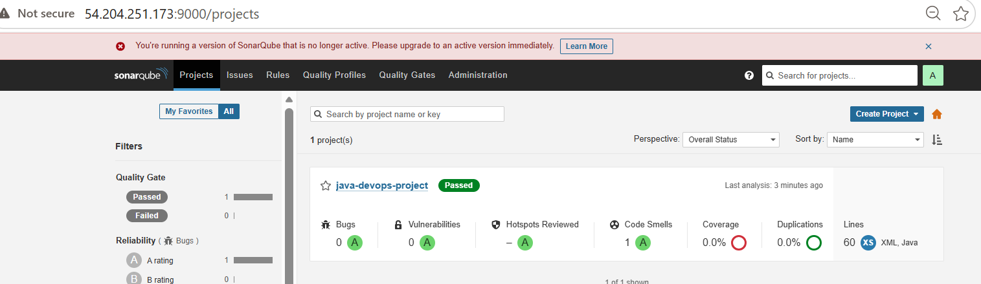
stage('Docker Build') {
steps {
sh 'docker build -t java-devops-project .'
}
}
}
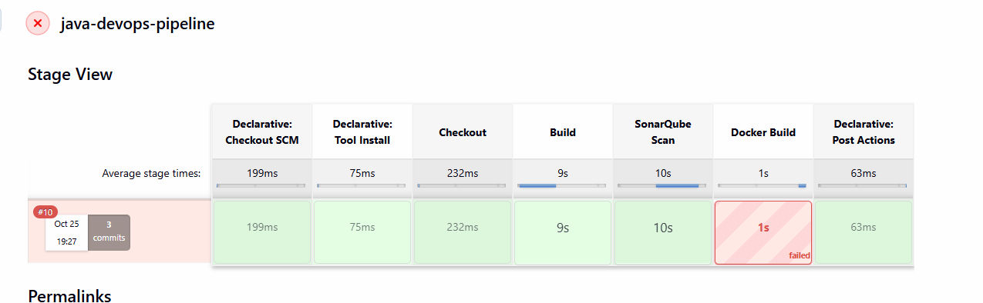
Add dockerfile contents:
FROM eclipse-temurin:21-jdk
WORKDIR /app
COPY target/*.jar app.jar
EXPOSE 8080
ENTRYPOINT ["java","-jar","app.jar"]
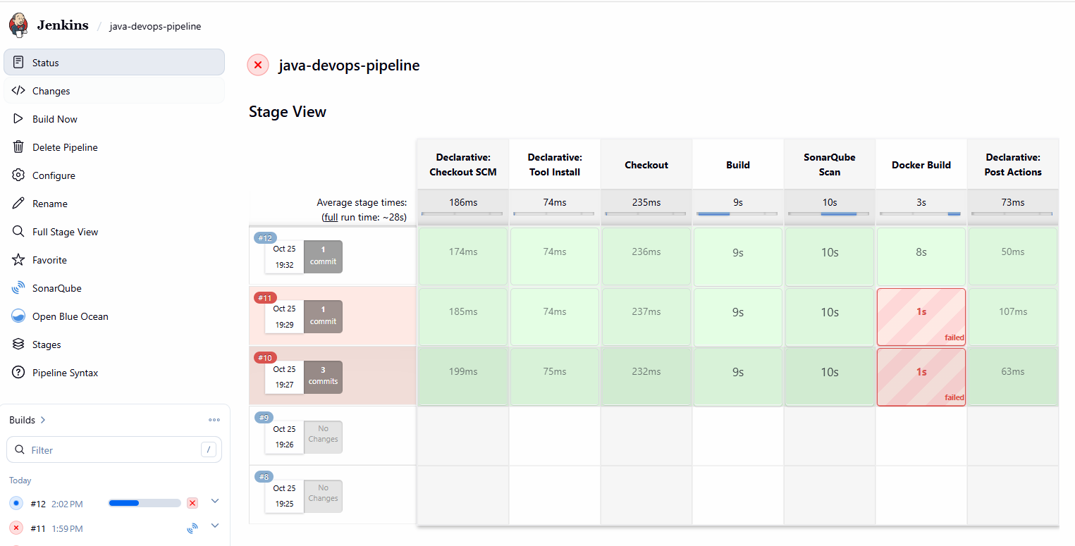
pipeline {
agent any

tools {
maven 'Maven3'
}

stages {

stage('Checkout') {
steps {
checkout scm
}
}

stage('Build') {
steps {
sh 'mvn clean package'
}
}

stage('SonarQube Scan') {
steps {
withSonarQubeEnv('SonarQube') {
sh '''
mvn org.sonarsource.scanner.maven:sonar-maven-plugin:5.8.0.7211:sonar \
-Dsonar.projectKey=java-devops-project
'''
}
}
}

stage('Docker Build') {
steps {
sh 'docker build -t java-devops-project .'
}
}
}

post {
success {
echo 'Build, SonarQube, and Docker Build Successful'
}

failure {
echo 'Pipeline Failed'
}
}
}

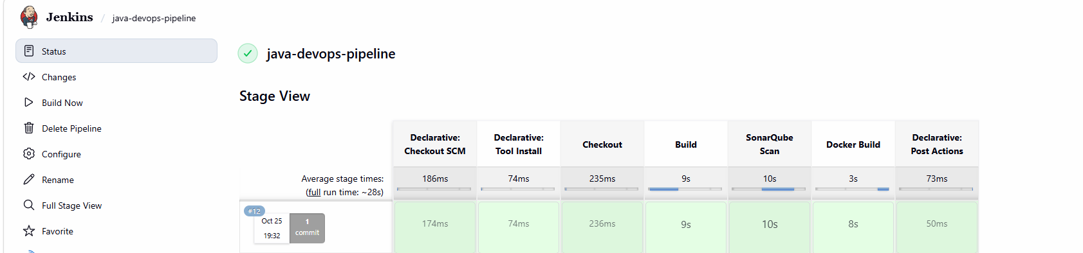
vi /var/lib/jenkins/.aws/config
[default]
region=us-east-1
output=json

vi /var/lib/jenkins/.aws/credentials
[default]
aws_access_key_id=YOUR_ACCESS_KEY
aws_secret_access_key=YOUR_SECRET_KEY
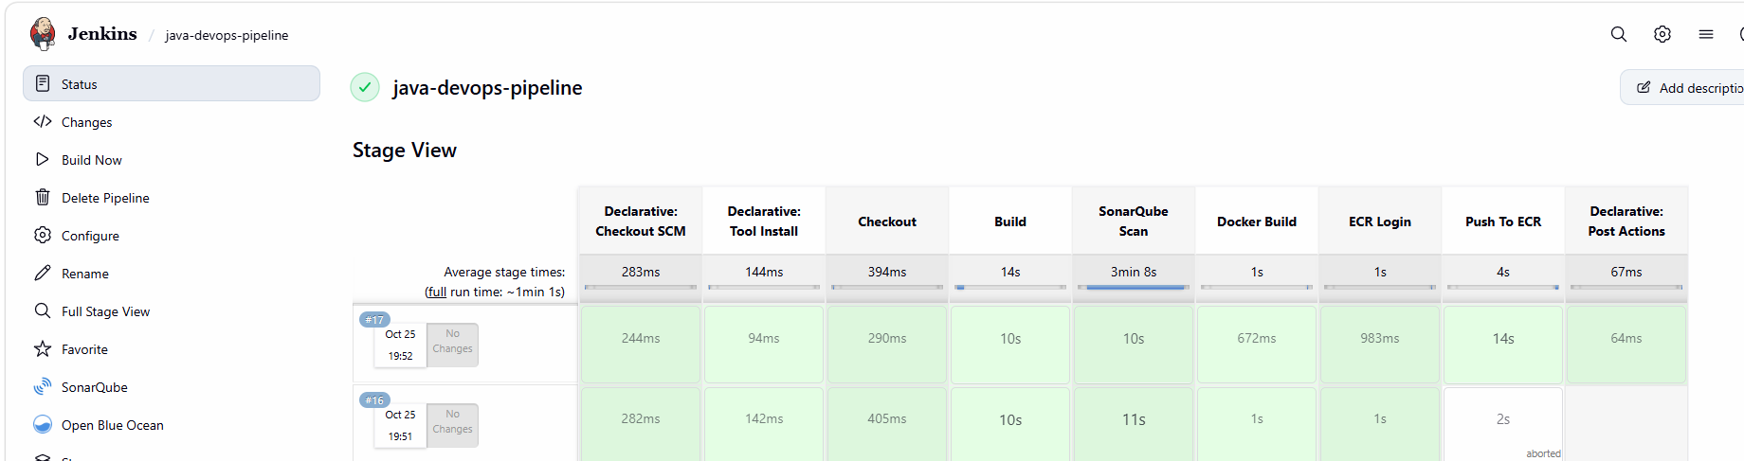

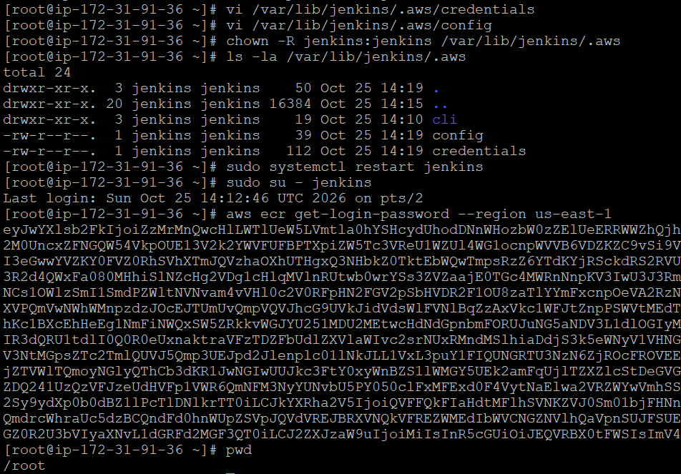
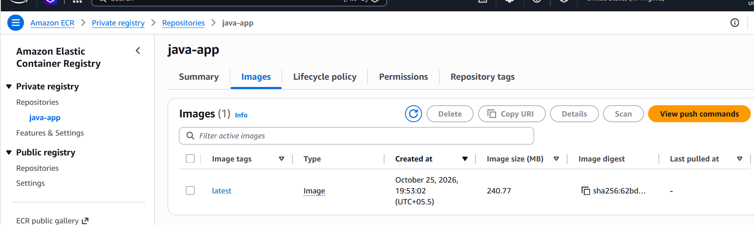

Login to appserver
Aws cli authenticate madde
Login Succeeded
[ec2-user@ip-172-31-18-79 ~]$ history
1 sudo -i
2 curl "https://awscli.amazonaws.com/awscli-exe-linux-x86_64.zip" -o awscliv2.zip
3 unzip awscliv2.zip
4 sudo ./aws/install
5 aws configure
6 docker --version
7 aws sts get-caller-identity
8 aws ecr get-login-password --region us-east-1 | docker login --username AWS --password-stdin 367842306906.dkr.ecr.us-east-1.amazonaws.com
docker pull 367842306906.dkr.ecr.us-east-1.amazonaws.com/java-app:latest
aws sts get-caller-identity
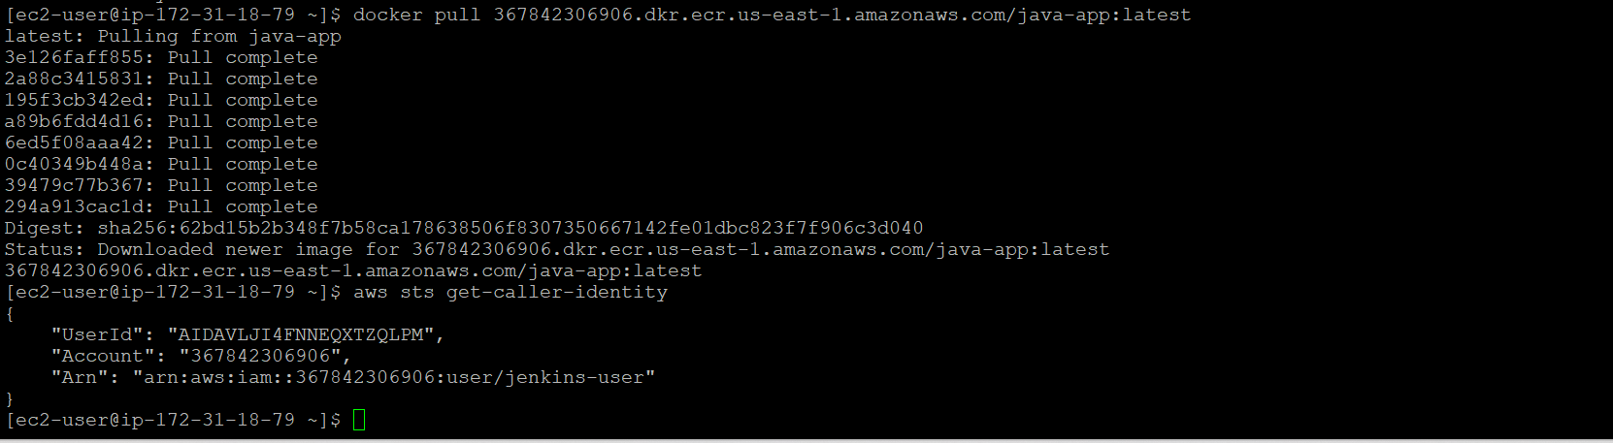

[ec2-user@ip-172-31-18-79 ~]$ docker images
REPOSITORY TAG IMAGE ID CREATED SIZE
367842306906.dkr.ecr.us-east-1.amazonaws.com/java-app latest 25ba6a97a7c3 33 minutes ago 496MB
[ec2-user@ip-172-31-18-79 ~]$ docker run -d --name java-app -p 8080:8080 367842306906.dkr.ecr.us-east-1.amazonaws.com/java-app:latest
9cfcb8034ba858a8d4b01da337011171930db03b5c0d1f96d0f459de9cd1a7ea
[ec2-user@ip-172-31-18-79 ~]$
[ec2-user@ip-172-31-18-79 ~]$ docker ps
CONTAINER ID IMAGE COMMAND CREATED STATUS PORTS NAMES
9cfcb8034ba8 367842306906.dkr.ecr.us-east-1.amazonaws.com/java-app:latest "java -jar app.jar" 22 seconds ago Up 20 seconds 0.0.0.0:8080->8080/tcp, :::8080->8080/tcp java-app
[ec2-user@ip-172-31-18-79 ~]$
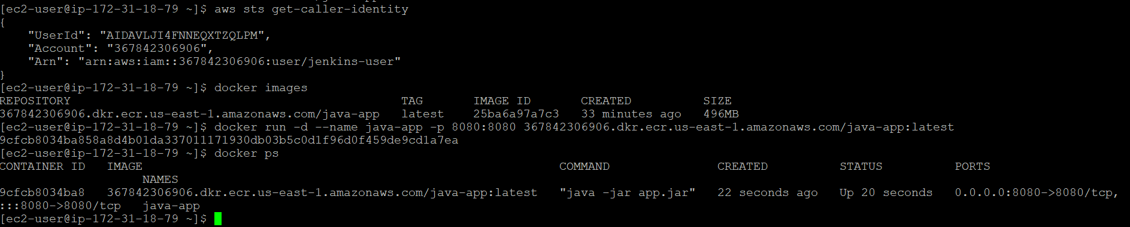
54.226.240.217:8080---application server output
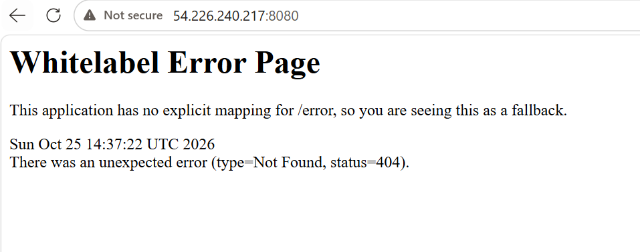
pipeline {
agent any

tools {
maven 'Maven3'
}

environment {
AWS_REGION = 'us-east-1'
ACCOUNT_ID = '367842306906'
ECR_REPO = 'java-app'
IMAGE_NAME = 'java-devops-project'
ECR_URI = '367842306906.dkr.ecr.us-east-1.amazonaws.com/java-app'
}

stages {

stage('Checkout') {
steps {
checkout scm
}
}

stage('Build') {
steps {
sh 'mvn clean package'
}
}

stage('SonarQube Scan') {
steps {
withSonarQubeEnv('SonarQube') {
sh '''
mvn org.sonarsource.scanner.maven:sonar-maven-plugin:5.8.0.7211:sonar \
-Dsonar.projectKey=java-devops-project
'''
}
}
}

stage('Docker Build') {
steps {
sh 'docker build -t java-devops-project .'
}
}

stage('ECR Login') {
steps {
sh '''
aws ecr get-login-password --region us-east-1 | \
docker login --username AWS --password-stdin \
367842306906.dkr.ecr.us-east-1.amazonaws.com
'''
}
}

stage('Push To ECR') {
steps {
sh '''
docker tag java-devops-project:latest $ECR_URI:latest

docker push $ECR_URI:latest
'''
}
}
}

post {
success {
echo 'Build, SonarQube, Docker Build and ECR Push Successful'
}

failure {
echo 'Pipeline Failed'
}
}
}

